Tweet from U.S. Mission to the United Nations Listing 49 States That Boycotted Durban V Commemoration
October 5, 2026
https://x.com/USUN/status/2107131720105636235

U.S. Mission to the UN
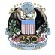

@USUN
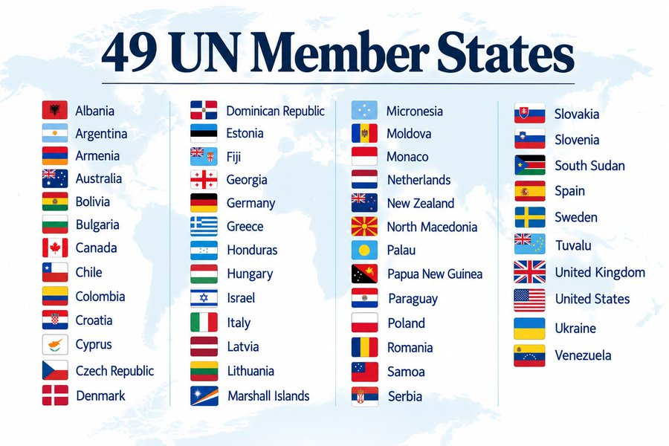
Make it 49 — thank you Marshall Islands

Quote
Ambassador Mike Waltz
@USAmbUN
·
Oct 1
48 UN Member States refused to participate in the UN’s shameful High-Level Meeting commemorating the 25th anniversary of the notorious anti-Western, antisemitic Durban Conference – nearly a quarter of the UN. This was a significant increase from 38 countries boycotting in 2021.
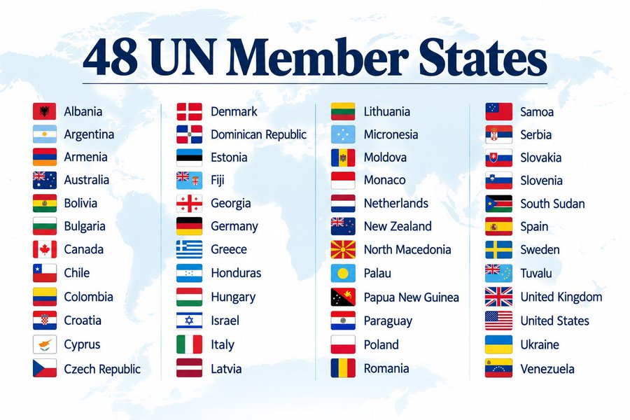

8:32 AM · Oct 5, 2026

