UN: Turning Back the Clock to Pre-1948 is the Real Endgame

December 17, 2014
By Anne Bayefsky
JPost

Incitement against the Jewish state is directly related to the stabbings, raping and killing of Jews inside and outside of Israel. But doing something to stop it requires confronting a very troubling fact: the global epicenter for incitement is the “human rights” leviathan, the United Nations.

From November 24, 2014 until December 5, 2014, UN human rights headquarters in Geneva mounted a public exhibit that was pure incitement. UN-driven antisemitism that takes the form of seeking to demonize, disable and ultimately destroy the Jewish state.

The exhibit was entitled: “La Nakba: Exode et Expulsion des Palestiniens en 1948” – or “The Nakba: Exodus and Expulsion of the Palestinians in 1948.” The occasion was the annual UN Day of Solidarity with the Palestinian People. Solidarity Day marks the adoption by the General Assembly on November 29, 1947 of the resolution that approved the partitioning of Palestine into an Arab and a Jewish state.

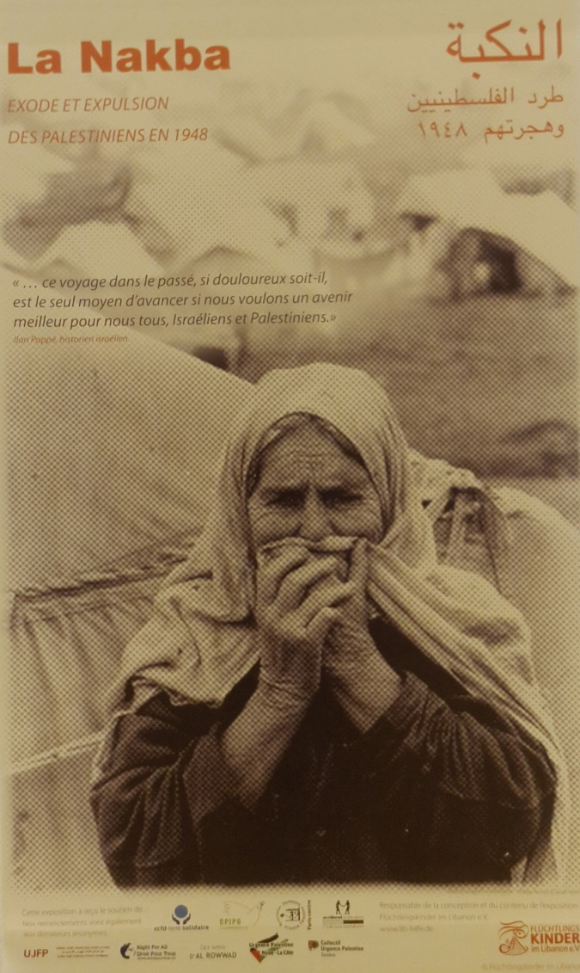

Introductory Poster, UN Nakba Exhibit, Palais des Nations, Geneva, 2014
The partition resolution was rejected by Arab states and celebrated by the Jewish people. Thus the Arab war to deny Israel’s right to exist began.

But in 2014, the UN overtly jettisoned the usual diplomatic lie that the 1967 occupation is the root cause of the Arab-Israeli conflict. The exhibit focused on the alleged crime of creating a Jewish state in 1948 and openly justified the rejection of the partition resolution.

The display was located in the UN’s Palais des Nations just outside the home room of the UN Human Rights Council. It consisted of 13 panels in French and an accompanying catalogue with English reproductions of each item. The catalogue was distributed by UN conference services.

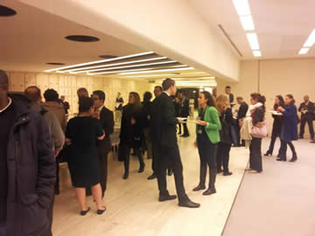

Reception beside the UN Nakba Exhibit, Palais des Nations, Geneva, Nov. 26, 2014

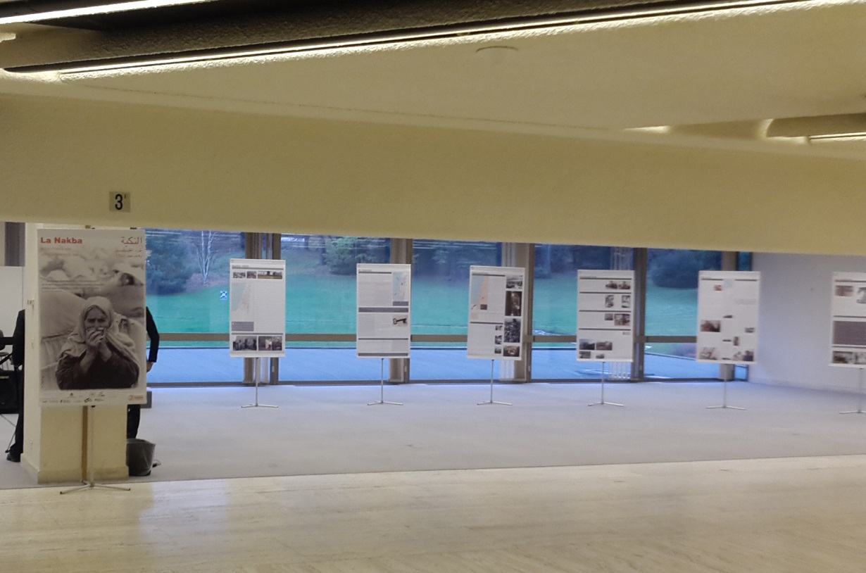

UN Nakba Exhibit, Exhibition Gallery, Palais des Nations, Geneva, Nov.-Dec. 2014
It turns out that the highly controversial exhibit has been circulating in churches and community centers in Germany, Austria and Switzerland since April 2008. Sought-after hosts like the City of Dusseldorf and the city library in Freiburg have refused the exhibit, which has also been formally criticized by the Mayor of Cologne.
The organization in charge of “design and content” for the exhibit is “Flüchtlingskinder im Libanon,” translated, “Refugee Children in Lebanon.” Ingrid Rumpf (aka Ingrid Hull), head of the organization and curator of the exhibit, explained her motivation in a 2011 interview by comparing Israelis to Nazis: "My involvement in the Palestinian problem is significantly influenced by my confrontation with Nazism.
Over the years, the litigious Ms. Rumpf has evidently enjoyed casting herself as a victim, launching repeated objections to bad press and other criticism over the exhibit before German courts and administrative tribunals.

In the exhibition catalogue, the organizer explicitly asks and answers the question: “Why did we create this exhibition on the Nakba?” The answer given: to reeducate all those whose “perceptions” have been “hindered” by “German guilt” and “the mass media” in order to “evoke understanding” that in 1948, Palestinians were “robbed of their homeland and their property.”

According to UN regulations, the exhibit was required to have been authorized by the highest UN authority in Geneva. UN guidelines spell out that a request – in this case from “the mission of Palestine” – must be sent to the Cultural Activities Committee of the UN Office in Geneva “who shall make recommendations for approval by the Director-General.” Michael Møller of Denmark.

In other words, the UN itself approved an exhibit proclaiming that “the partition resolution violates fundamental principles of the U.N. Charter.”

According to the exhibit, the problem with the partition plan was that it was prepared and adopted “without consulting the Palestinian people,” and “the General Assembly is not authorized to pass binding laws or create new states.”

Actually, the General Assembly decision not to hand Arab rejectionists a veto over Jewish self-determination was deliberate and well-justified. And the partition resolution never purported to be a law or “create” a state. The resolution represented a stamp of moral and political approval for the creation of Israel, which was accomplished by a declaration of its own people almost six months later.

The “source” identified in the exhibit for this bogus contention is one Norman Paech. He is a former German Left Party parliamentarian, who distinguished himself by voting against a 2008 resolution establishing a committee to report on antisemitic crimes and to support the growth of Jewish life in Germany. A prolific inciter, Paech has also claimed that there is a “right to armed resistance” against anyone living in a Jewish settlement, Israel is an “apartheid state,” and Israel waged “a war of extermination” in Lebanon.

The UN-sponsored exhibit contains a litany of other fabrications and hate speech.

These include: “The roots of the Palestine problem date back to the late nineteenth century, when…Zionism developed in Europe.” “The Balfour Declaration was legally, politically, and morally dubious.” The 1948 war consisted of “acts of terrorism…by the Zionists.” Jews were busy conducting "massacres," while Arabs were busy fleeing. The “leading Zionist representatives headed by the subsequent Prime Minister of Israel David Ben Gurion, planned and implemented the ethnic purge.”

The case for Arab rejection of a Jewish state, indicates the exhibit, is that “the Palestinians failed to see why they should be made to pay for the Holocaust.”

The exhibit used the word “indigenous” only to describe Arabs and their “ancestral soil.” The presence of Jews, and the association of Judaism with the land of Israel, for almost 4,000 years were never mentioned.

Palestinians, the exhibit claims, were “an entirely uninvolved people” in Nazi persecution of Jews. In fact, the Grand Mufti of Jerusalem, Haj Amin al-Husseini, closely collaborated with the Nazis. Living lavishly under German auspices during much of the war, and still considered a hero by many Palestinians, al-Husseini pressed Hitler to extend his solution of the Jewish problem to Palestine.

Nowhere in its history of Israel’s creation is there any mention that the armies of five neighboring Arab states – exclusively equipped with the standard weapons of a regular army – invaded the day old Jewish state on multiple fronts. Instead, the exhibit gives a revisionist account of impoverished Arab “troop strength.”

As for the 800,000 persecuted Jews who were forced to flee Arab states, the exhibit blames Israel: “Israel’s expansionist policy had grave effects on the mainly peaceful coexistence of Muslims, Jews and Christians that had prevailed for centuries in the Arab countries of Asia and Africa. The result was massive immigration of Jews from these countries to Israel.”

The exhibit concludes with the final message that Israel is the “lost homeland” of Palestinians to which they are “longing” to return. The visual images include signs saying “no return = no peace” and pictures of a title deed and front door key.

Nowhere does the exhibit talk about recognition of, and peaceful co-existence with, the Jewish state.

UN Nakba Exhibit, Geneva, “15 May 2000, Nakba Remembrance Day”

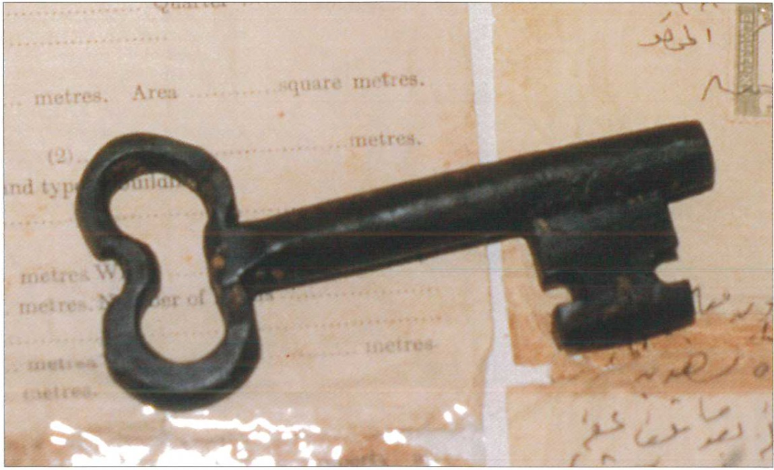

UN Nakba Exhibit, Geneva, “Title deed and front door key of Palestinian refugees, Lebanon”

The sources for all the falsehoods in this UN-hosted exhibit are clearly acknowledged and are a veritable who’s-who of anti-Israel and anti-Jewish extremists, like Ilan Pappe, Walid Khalidi, Uri Davis and Salman Abu Sitta. A mere glance at their extensive contributions to bigotry would have revealed the exhibit’s fraudulence to UN officials, had they cared:
Ilan Pappe: “1948…Zionist leaders…put the final touches on a plan for the ethnic cleansing of Palestine…[E]thnic cleansing ...has been practiced from biblical times to the modern age, including…in World War II by the Nazis…The problem with Israel…is its ethnic Zionist character.” (Journal of Palestine Studies, 2006; author of “The Ethnic Cleansing of Palestine”)
Walid Khalidi: "The unity that currently exists in Jerusalem is the unity of an Anschluss" [the annexation of Austria by the Nazis in 1938]…The Zionist leadership "accepted" partition, but this acceptance was only verbal. At the same time they prepared a master plan...for military conquest.” (statement to the United Nations, NY, November 30, 2009)
Uri Davis: “The core of the Israeli-Palestinian conflict is a conflict between a settler colonial state of Israel informed by political Zionist apartheid ideology and characterized by political Zionist ethnic cleansing practices, on the one part, and the indigenous people of the country of Palestine, the Palestinian Arab people, on the second part…”
Salman Abu Sitta: “Palestine is the patrimony of Palestinians…In spite of British collusion and Jewish wealth…Palestinians will never accept foreign intruders…Zionism is a colonial project… Colonial projects cannot last. Zionism has implemented the largest comprehensive ethnic cleansing in modern history.” (“Re-Constructing Palestine: Reversing Ethnic Cleansing, Right of Return Conference; April 2013)
For her efforts in transforming such a group of pathological xenophobes into UN authorities, the day before the exhibit opened at the UN, the Palestinian Community in Germany awarded Rumpf with the “Palestine Solidarity Prize.” The presenter thanked her for the exhibit and its message, which he encapsulated this way: "The Palestinians are the last victims of the Holocaust.”

Another showing of the exhibit earlier this year was opened by Hans-Christof von Sponeck – a former UN official disgraced by having personally benefitted from working against sanctions on Saddam Hussein’s Iraq. In his opening remarks, von Sponeck said: “Maybe the time will come when Palestinians…and Israelis…will join hands in mounting a joint Naqba & Shoa exhibition…”
In defense of the exhibit, Rumpf herself lined up and distributed at the UN a list of supporters. They included Jean Ziegler, who launched the annual Muammar Qaddafi Human Rights Prize in 1989 four months after Libya bombed Pan Am flight 103, received the prize himself along with a French Holocaust denier in 2002, embraced and advised dictators from Castro to Mugabe, and called Gaza “an immense concentration camp.”

The exhibit also proudly identifies the NGOs from which it “has received support.” They include organizations such as “Right for All,” which shout about Israeli “ethnic cleansing,” and “crimes against humanity, and claim that the problem all started with “the Zionist occupation in 1948.” Their solution? “All Palestine must be liberated.”

Recent work by exhibition backer the Association France Palestine Solidarité (AFPS) includes the publication of a series of “beautiful posters” – to use the words of its president Taoufik Tahani – on the Gaza war in September 2014. Posters like “Bibi dans son bain,” which portrays Israeli Prime Minister Bibi Netanyahu soaking over his head in Palestinian blood.



“Bibi dans son bain” September 2014 issue of Humanity, co-produced by exhibition partner the Association France Palestine Solidarité (AFPS)

And then there is exhibition backer “Collectif Urgence Palestine” whose website boasts a poster depicting Israel as a blood-dripping weapon that must be stopped.

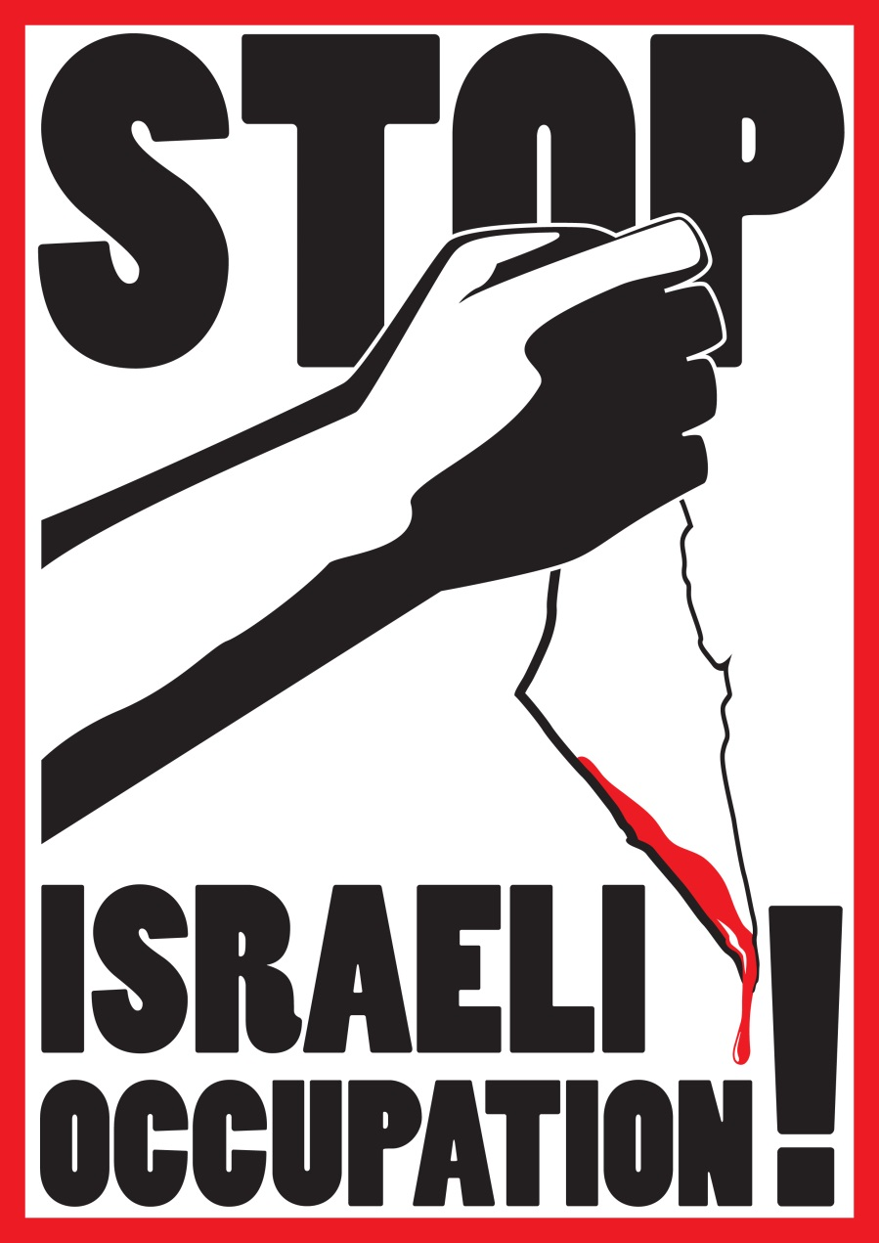

Poster on the site of exhibition partner “Collectif Urgence Palestine”
With the United Nations having welcomed the exhibit with open arms – notwithstanding its vile purposes, partners, supporters and fact-checkers – the organizers hit the jackpot. On November 23, 2014, Rumpf gushed: “I very much hope that the Nakba exhibition will encounter in the future strong demand…[Its] appearance…in the Palace of the United Nations in Geneva, where it is shown on the occasion of the International Day of Solidarity with the Palestinian People, should completely remove serious doubts about its reliability...”

UN rules state that cultural activities seeking a UN platform must “promote dialogue among civilizations” and “be compatible with the values, purposes and principles of the United Nations.”

Apparently, a direct attack on the legitimacy of the UN member state of Israel is now interpreted in UN circles as consistent with the principles of the United Nations.

Maybe, so long as those principles have nothing to do with truth, equality, and justice.

The silence of UN members on this abomination is deafening.

