United Nations Lists Every Combatant As “Civilian”

March 17, 2025

By Gilead Ini

CAMERA Committee for Accuracy in Middle East Reporting

<https://www.camera.org/article/united-nations-pretends-combatants-are-all-civilians/>

According to the United Nations, these are photos of civilians:

[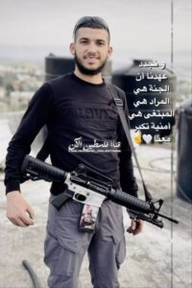](https://www.camera.org/wp-content/uploads/2025/03/Ahmed-Abu-Obeid.jpeg)

Ahmed Abu Obeid

[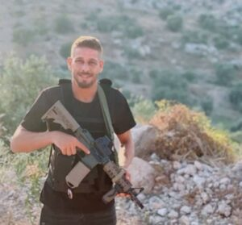](https://www.camera.org/wp-content/uploads/2025/03/Saqer-Abed.jpeg)

Saqer Abed

[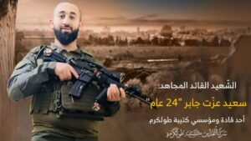](https://www.camera.org/wp-content/uploads/2025/03/Izat-Jaber.jpeg)

Said Izzat Jaber

Which is odd, because Ahmed Abu Obeid and Saqer Abed were Islamic Jihad gunmen, killed in June 2024 during what the terror group [described](https://www.aljazeera.com/news/2024/6/11/israeli-forces-kill-six-palestinians-in-west-bank-raid#:~:text=The%20Jenin%20battalion%20of%20the%20al%2DQuds%20Brigades%20%E2%80%93%20the%20armed%20wing%20of%20the%20Palestinian%20Islamic%20Jihad%20%E2%80%93%20had%20said%20earlier%20on%20Tuesday%20that%20it%20was%20engaged%20in%20%E2%80%9Cfierce%E2%80%9D%20fighting%20with%20Israeli%20troops%20in%20Kafr%20Dan.) as a ‘fierce’ battle with Israeli soldiers. And Said Izzat Jaber, killed that same month, was a senior Islamic Jihad terrorist.

If we zoom out to look at the whole month, it becomes clear that these are hardly the only casualties misclassified by the UN. In fact, the United Nations Office for the Coordination of Humanitarian Affairs (OCHA), the primary body that [tallies and characterizes](https://www.ochaopt.org/data/casualties) Palestinian casualties, currently insists every single West Bank Palestinian killed by Israel in June was a civilian. The [Hamas](https://english.alarabiya.net/News/middle-east/2024/06/11/hamas-says-one-of-its-commanders-was-killed-in-clash-with-israeli-forces-in-west-bank) [commander](https://x.com/k________om/status/1800419140139704721/photo/1)? A civilian. The [Al Aqsa Martyrs Brigade](https://www.palestinechronicle.com/west-bank-update-israeli-forces-kill-five-palestinians-mass-raids-homes-demolished/#:~:text=In%20a%20statement%20by%20the%20Al%2DAqsa%20Martyrs%20Brigades%2C%20the%20movement%20confirmed%20the%20killings%20of%20Ahmad%20Mustafa%20Rajab%20and%20Abdulfattah%20Salah%20Al%2DDin%20Jabara%2C%20during%20%E2%80%9Ca%20shooting%20operation%E2%80%9D%20at%20the%20checkpoint.) [gunmen](https://x.com/no_itsmyturn/status/1797991020908486951/photo/1)? Civilians. [The Islamic Jihad militants](https://www.timesofisrael.com/liveblog_entry/islamic-jihad-names-jenin-terror-leaders-killed-in-clash-with-idf/)? Civilians. The [Hamas attackers](https://palinfo.com/news/2024/06/11/893809/#:~:text=%D9%88%D8%B4%D9%87%D9%8A%D8%AF%D9%87%D8%A7%20%D8%A7%D9%84%D9%85%D8%AC%D8%A7%D9%87%D8%AF%20%D8%A7%D9%84%D9%82%D8%B3%D8%A7%D9%85%D9%8A%20%D9%85%D8%AD%D9%85%D8%AF%20%D8%B1%D8%B3%D9%84%D8%A7%D9%86%20%D8%B9%D8%A8%D8%AF%D9%87%D8%8C%20%D9%88%D8%B4%D9%87%D9%8A%D8%AF%D9%87%D8%A7%20%D8%A7%D9%84%D9%85%D8%AC%D8%A7%D9%87%D8%AF%20%D9%88%D8%B3%D9%8A%D9%85%20%D8%A8%D8%B3%D8%A7%D9%85%20%D8%B2%D9%8A%D8%AF%D8%A7%D9%86%20%D8%A3%D8%A8%D9%88%20%D8%B9%D8%A7%D8%AF%D9%8A%D8%8C%20%D9%88%D8%B4%D9%87%D9%8A%D8%AF%D9%87%D8%A7%20%D8%A7%D9%84%D9%85%D8%AC%D8%A7%D9%87%D8%AF%20%D8%B1%D8%B4%D8%AF%D9%8A%20%D8%B3%D9%85%D9%8A%D8%AD%20%D8%B9%D9%85%D8%B1%20%D8%B9%D8%B7%D8%A7%D9%8A%D9%87%D8%8C%20%D8%A7%D9%84%D8%B0%D9%8A%D9%86%20%D8%A7%D8%B1%D8%AA%D9%82%D9%88%D8%A7%20%D9%81%D9%8A%20%D8%A7%D8%B4%D8%AA%D8%A8%D8%A7%D9%83%20%D9%85%D8%B3%D9%84%D8%AD%20%D9%85%D8%B9%20%D9%82%D9%88%D8%A7%D8%AA%20%D8%A7%D9%84%D8%A7%D8%AD%D8%AA%D9%84%D8%A7%D9%84%20%D8%A8%D9%85%D9%86%D8%B7%D9%82%D8%A9%20%D9%83%D9%81%D8%B1%20%D9%86%D8%B9%D9%85%D8%A9%20%D8%BA%D8%B1%D8%A8%20%D8%B1%D8%A7%D9%85%20%D8%A7%D9%84%D9%84%D9%87.)? Civilians.

For that month, OCHA lists 34 West Bank fatalities, classifying all as civilians. B’tselem [concurs](https://statistics.btselem.org/en/all-fatalities/by-date-of-incident/pal-by-israel-sec/west-bank?dateSensor=%221717210800000,1719791999000%22&tab=overview) with the number, but in detailing the circumstances of each death makes clear that the vast majority were combatants.

[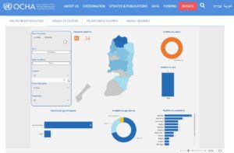](https://www.camera.org/wp-content/uploads/2025/03/ocha-june-2024-all-34-civilians.jpg)

According to the UN’s casualty portal, all 34 of the West Bank fatalities were ‘civilians.’

The UN’s wholesale misinformation remains when zooming further. In fact, according to OCHA, each and every conflict-related death in the West Bank since January 2008 (the earliest searchable date on its casualty portal) was a civilian.

[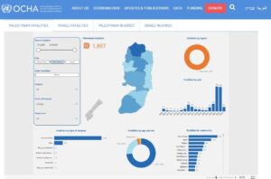](https://www.camera.org/wp-content/uploads/2025/03/ocha-since-jan-2008-1897-civilian.jpg)

The UN casualty portal classifies every one of the [1,897 West Bank fatalities](https://www.camera.org/wp-content/uploads/2025/03/ocha-since-jan-2008-1897-all.jpg) it counts since 2008 as ‘civilian.’

The extent of the misinformation has varied somewhat over the past few weeks. We first checked the portal on March 6, [after](https://x.com/GileadIni/status/1897394851144188187) a *New York Times* story cited UN casualty figures. Though OCHA didn’t acknowledge a single fatality was a member of an ‘armed group’ and insisted that every death prior to June 2024 was a civilian, it had at least allowed for the *possibility* that some post-June 2024 casualties weren’t civilians, [categorizing](https://x.com/GileadIni/status/1897394855518855389) several hundred casualties under the label ‘Dispute.’ But at some point between then and now, even these *’*disputed’ casualties became *’*civilians.’

The most generous interpretation might be that a technological glitch erased the combatants. Such generosity, though, might not be warranted. Even away from the OCHA portal, the United Nations has sought to conceal the many armed terror operatives among Palestinian casualties. In a June 4, 2024 [statement](https://media.un.org/unifeed/en/asset/d321/d3214000), for example, UN Human Rights Chief Volker Türk and his spokesman Jeremy Laurence referenced the 505 Palestinians killed in the West Bank since Hamas’s Oct. 7, 2023 attack, chastising Israel for what they called ‘unacceptable’ and ‘wanton’ killing without offering a hint that any of the casualties were members of terror groups, or were involved in anything more than ‘throwing stones, incendiary bottles, and firecrackers.’

The UN officials whitewashed the reality, which included intense combat. In the month prior to their statement, for example, 28 (per B’tselem) or 29 (per OCHA)ⓘ Palestinians killed in the West Bank, including: three Hamas operatives, one Islamic Jihad gunman, and one a Lion’s Den militant killed in exchanges of fire; one senior Islamic Jihad terrorist; three Palestinians killed during attempted stabbing attacks on Israeli security officials; at least four killed while throwing explosives; and an armed man. These made up over half of the month’s fatalities. Additionally, one was killed while throwing stones;  one killed while throwing either stones or explosives, and according to Israel three others had been planting explosives.ⓘ (Details via [B’tselem](https://statistics.btselem.org/en/all-fatalities/by-date-of-incident/pal-by-israel-sec/west-bank?dateSensor=%221714532400000%2C1717199999000%22&tab=overview).)

A month earlier, in [April 2024](https://statistics.btselem.org/en/all-fatalities/by-date-of-incident/pal-by-israel-sec/west-bank?dateSensor=%221711940400000%2C1714521599000%22&tab=overview), the 26 (per B’tselem) or 29 (per OCHA) Palestinians killed included: a senior Hamas militant; eleven Islamic Jihad gunmen killed during exchanges of fire; two other gunmen; three Palestinians who attempted to stab Israeli security forces; two who threw explosives; and one who might have been inadvertently killed by Islamic Jihad gunmen. These made up about 75 percent of the month’s fatalities.

Given how frequently UN casualty figures are cited in media, OCHA’s widespread misclassification of casualties could have far-reaching consequences. By labeling armed militants as ‘civilians,’ OCHA cultivates a misleading narrative that obscures the reality of armed clashes with terror groups, and instead portrays Israel as engaging in indiscriminate violence against civilians. Given how Volker Türk has talked about the violence, one might wonder if this misimpression is precisely what UN officials want.

We’ve informed OCHA of its errors and asked about their provenance and duration. We’ll update this space with any response.