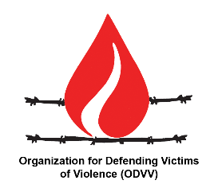
Organization for Defending Victims of Violence

Item 2: ID with COI on OPT

Madam High Commissionaire
We have followed with great interest and welcome the establishment of the Independent International Commission of Inquiry on the Occupied Palestinian Territory. The initial report clearly indicated that the continuation of the Israeli "belligerent occupation" of the OPT and the "continued discrimination" against Palestinians are the root causes behind recurrent tensions, instability and prolongation of conflict in the region.

Unfortunately, perpetration of racial discrimination, ethnic cleansing, forced displacement, house demolition and field killings that have claimed the lives of 64 Palestinians since the beginning of the year, one third of them being children and women, including assassination of journalist Shereen Abu Aqleh continue in the OPT and "credible evidence" shows that "Israel has no intention of ending the occupation".

The time has come for the international community to stop silence and the failure to activate accountability mechanisms and seriously boycott Israel to prevent it from continuing crimes against civilians and civilian objects in occupied Palestine.
ODVV urges the Human Rights Council and the international community to endorse the report of the COI on OPT; implement its recommendations and ensure that the report is transmitted to other international bodies such as the General Assembly and the International Criminal Court.

. A/HRC/50/21, pp. 70.

