PA intentionally submits falsified document to the International Criminal Court

June 17, 2020
By Maurice Hirsch
Palestinian Media Watch
https://palwatch.org/page/17971
The latest submission by the Palestinian Authority to the International Criminal Court (ICC) is a prime example of how the PA tailors and changes the content of the speeches of its leaders, and its positions in general, depending on the identity and perceived naïveté of the target audience.
In this instance, while speaking in Arabic to the Palestinian audience PA Chairman Mahmoud Abbas, in his May 19, 2020 speech, declared that as of that day, the PA no longer sees itself obligated by the accords and agreements signed with Israel. In contrast, in the PA submission to the ICC, Abbas’ declaration suddenly became conditional on a future event.
These contradictory claims were, however, merely the tip of the iceberg, with the PA’s submission.
While the PA claims to have attached to its submission a translation of Abbas’ speech, Palestinian Media Watch has found that the document attached is not a transcription of the speech. Rather it is a falsified version, intentionally edited by the PA to mislead the court. The falsified document also conveniently omits Abbas’ confession to committing crimes.
The PA double-speak and submission of a falsified document to the ICC, should result in the court rejecting all the different arguments put forward by the PA, simply because it is impossible to rely on any of their statements and ascertain their true position on any given subject.
PA double-speak
Responding to the order of the ICC Pre-Trial Chamber (PTC) “to provide additional information on this statement [by Abbas cancelling all agreements with Israel], including on the question whether it pertains to any of the Oslo agreements between Palestine and Israel,” the PA opened by attacking the decision of the court saying that “it is not readily apparent from the Order which issue(s) raised in the President’s statement (‘the Statement’) the court specifically wishes to address in the context of these proceedings.” The PA then admonished the court, claiming that its submission had already been made on March 16, 2020, and that as such the court should have blindly ignored Abbas’ speech, even if it fundamentally contradicted previous submissions.
On the subject of Abbas’ cancelling all agreements, the PA wrote:
“Substantively, the Statement declares that if Israel proceeds with annexation, a material breach of the agreements between the two sides, then it will have annulled any remnants of the Oslo Accords and all other agreements concluded between them.”
[PA submission to ICC - PTC, June 4, 2020
https://www.icc-cpi.int/CourtRecords/CR2020_02277.PDF]
[Emphasis added]
In other words, according to the PA’s submission to the PTC, Abbas’ declaration to end the agreements between Israel and the PLO is conditional, on Israel proceeding “with annexation”.
This statement is clearly different from what Abbas’ actually said, not only in his written speech but also in his broadcast speech.
“The Palestine Liberation Organization and the State of Palestine are absolved, as of today, of all the agreements and understandings with the American and Israeli governments and of all the obligations based on these understandings and agreements, including the security ones.”
[Wafa, Official PA News Agency, May 19, 2020,
Official PA TV, May 19, 2020]
[Emphasis added]
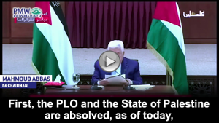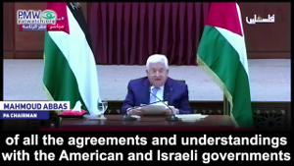
The PA double-speak is also manifest in its actions.
Since the declaration - or more accurately, despite the declaration - the PA, which is solely a creation of the Oslo Accords, has continued to function. Mahmoud Abbas (now in his fifteenth year of a four year term), has not resigned his position and still conducts himself as Chairman of the PA. The PA cabinet, headed by PA Prime Minister Mahmoud Shtayyeh, still convenes. Neither Shtayyeh nor any of the other PA cabinet ministers have resigned their positions. So too, the PA security forces, have not handed in their weapons.
Needless to say, a mere press conference, unaccompanied by official documentation – such as a signed document declaring the dissolution of the PA – or specific implementing actions, would not necessarily meet the legal standards required to end the agreements the Palestinians entered into with Israel.
In contrast, following the declaration, the PA ostensibly adopted a number of actions.
The day after Abbas’ declaration, Shtayyeh held an “emergency cabinet meeting” to discuss the decision. The press release from Shtayyeh’s office following the meeting said:
“During the meeting, Prime Minister Dr. Mohammad Shtayyeh confirmed the Palestinian government's full support to the decision announced yesterday by H.E. President Mahmoud Abbas and the Palestinian leadership that we are absolved of all signed agreements and understandings with the Israeli and American sides. The Prime Minister stressed that we would work on translating this decision on the ground.”
[Office of the PA PM, Press release, May 21, 2020
(http://www.palgov.ps/en/article/230/Remarks-by-Prime-Minister-Dr-Mohammad-Shtayyeh-During-the-Emergency-Cabinet-Meeting)]
Shtayyeh made similar remarks in the PA cabinet meeting the following week.
“Today, the Cabinet will finalize plans related to the leadership’s decision, headed by President Mahmoud Abbas, that Palestine is absolved of all agreements with Israel.”
[Office of the PA PM, Press release, June 1, 2020 (http://www.palgov.ps/en/article/231/Remarks-by-Prime-Minister-Dr-Mohammad-Shtayyeh-at-the-Weekly-Cabinet-Meeting)]
Pursuant to the cabinet meeting, PA Head of Civil Affairs, Hussein Al-Sheikh, announced that the PA was refusing to accept the tax income which Israel agreed, as part of the financial agreement with the PLO (otherwise known as the 1994 Paris Accords) to relinquish in favor of the PA. The announcement clearly shows that the PA/PLO see Abbas’ declaration as having immediate effect:
“we refused and continue to refuse receiving the clearance funds due to the decision of the Palestinian leadership that we no longer have agreements with the government of Israel.
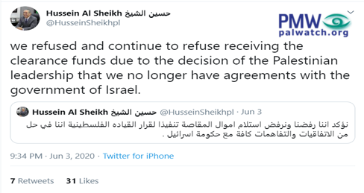
[Twitter of Hussein Al Sheikh, June 3, 2020]
From the above it is clear that both the statements and actions of the PA are self-contradictory.
On the one hand, from May 19, 2020, Abbas absolved himself, the PLO and the PA of the agreements the Palestinians signed with Israel. The PA even adopted limited measures to implement this decision.
On the other hand, in its submission to the ICC-PTC the PA backtracks, saying that the annulment of the agreements is conditional on a future act that may, or may not, be carried out by Israel. This PA position is also supported by PA acts on the ground.
Submitting a false document and confessing to committing crimes
There are two versions of Abbas’ speech - The actual speech he made and the version the PA claims in its submission to be the speech delivered by Abbas “Translated from Arabic” specifically for “clarification purposes in the context of the proceedings before the International Criminal Court.”
While over two weeks passed between Abbas’ speech and the PA submission, (the speech was made on May 19 and the PA made its submission on June 4) the speech attached by the PA was not a full and accurate transcript of the speech itself.
The misleading speech, intentionally attached by the PA to its submission, is similarly part of the PA’s calculated attempt to tailor, cater and manipulate the arguments it presents to different fora.
In Arabic, to its domestic audience, Abbas intentionally adopted a hardline approach making additional references to subjects and messaging he felt important to highlight. In contrast, the English “translation”, prepared by the PA and directed at the ICC-PTC panel, omits, despite the time lapse, key elements of Abbas’ speech.
One of the most fundamental differences between the PA’s version of Abbas’ speech and Abbas’ actual speech, was his commitment to continue paying cash rewards to Palestinian terrorists, including mass murderers’ and to the families of dead terrorists (so-called “Martyrs”), which the ICC Prosecutor has already written may be a crime against humanity.
The PA’s version of the speech submitted to the ICC, contained only a limited reference to the “Martyrs” and “heroic prisoners”:
“Eighth: … We pledge to our honoured martyrs, our brave prisoners and our heroic wounded to remain faithful to our oath until victory, freedom, independence and return are achieved...”
In contrast, in his full speech, Abbas added the following words:
“Currently, [the Israelis] have asked the banks not to pay the prisoners. We will pay the prisoners, and let [the Israelis] just try to stop us (literally: “against the will of their father”)”
The PA thought this part was so important that they turned it into a short video clip that was rebroadcast on official PA TV:
Abbas: “We vow to our honorable Martyrs and heroic prisoners – [The Israelis] have asked the banks not to pay the prisoners, [but] we will pay the prisoners, no matter what they [the Israelis] want.”
[Official PA TV, Abbas’ original speech on May 19, 2020,
filler 5 times on May 20, 2020]
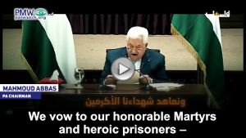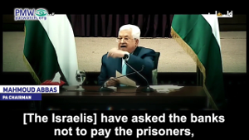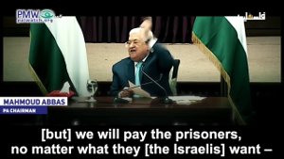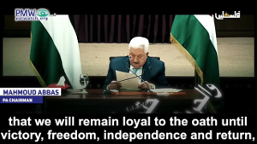
The payments that Abbas promised to pay in his speech, are clear terror support. The ICC Prosecutor has noted that by paying salaries to terrorists the PA has “encouraged and provided financial incentives for the commission of violence through their provision of payments to the families of Palestinians who were involved, in particular, in carrying out attacks against Israeli citizens, and under the circumstances, the payment of such stipends may give rise to Rome Statute crimes.” (ICC Prosecutor Report on Preliminary Examination Activities, 2019).
Since the PA has an inherent interest in not submitting a confession that Abbas and his PA are committing crimes in breach of the Rome Statute, it is clear why the PA submitted the incorrect version of the speech to the ICC.
Recently, Palestinian Media Watch exposed the collusion between the PA and ICC Proseuctor, Fatou Bensouda. As part of that collusion, Bensouda’s request was basically a sham, as she reportedly told the PA representatives that her request to the PTC was, submitted only “out of considerations related to protecting the ICC's public image” but that the decision “is a foregone conclusion.”
Does the PA’s brazen falsifications to the ICC indicate that it assumes that the ICC-PTC itself is biased in its favor, as is Bensouda, that it feels it can lie to the ICC without there being consequences?
Since the PA has lied to the ICC by falsifying the content of Abbas’ speech, to avoid further damage to the ICC’s image and to ensure that justice is done, the PTC should immediately nullify the PA’s false submission and reject the request of Bensouda, and once and for all put an end to the politicization of the ICC.
The PA submission was ordered by the Pre-Trial Chamber (PTC) of the ICC after Abbas’ May 19 speech, in all likelihood, as a result of the conflicting and sometimes contradictory arguments put forward by the ICC Prosecutor, Fatou Bensouda, regarding the relevance and importance of the Oslo Accords on the discussion whether the “State of Palestine” exists and whether that entity is capable of delegating criminal jurisdiction to the ICC.
In the submission of Palestinian Media Watch, together with other organizations, regarding the original request of Bensouda to open an investigation against Israel, we argued that there is no “State of Palestine”. We further argued that in the Oslo Accords the Palestine Liberation Organization (also headed by Abbas) specifically agreed that no such state would be created and that it would be a fallacy to see the PA as the embodiment of such a state. We further argued that since the Oslo Accords did not provide the PA with any criminal jurisdiction over Israelis, the PA could certainly not delegate its non-existent jurisdiction to the ICC.
In its March submission, the PA all but ignored the Oslo accords, most probably understanding that the existence of the Accords would be a clear obstacle to the ICC jurisdiction.
As noted above, PA double speak is not uncommon. Abbas himself tailors and adapts his message according to his audience.
When talking to a group of visiting Harvard students about a future division of Jerusalem and the religious rights of Jews, Muslims and Christians, Abbas declared that all three are equal and should be able to practice religion in an equal fashion:
"We are honestly not against the Jews. No. The Jews, the Christians, the Muslims - for us they are equal...
Regarding East Jerusalem, we will say that East Jerusalem is the capital of Palestine, West Jerusalem is the capital of Israel, and between them is a kind of cooperation. But the holy sites will remain open to the three [monotheistic] religions at all times., And it will be forbidden to prevent any person - Christian, Jew, Muslim - from going and performing his religious rituals."
[Official PA TV, March 24, 2019]
This directly contradicts a previous statement made by Abbas, in which he explicitly called for Palestinian violence to prevent Jews from going to Judaism's holiest site - the Temple Mount. Abbas said he blessed "every drop of blood spilled for Jerusalem" and added that the Al-Aqsa Mosque, which the PA claims includes the entire Temple Mount, belongs to the Muslims alone, and which the Jews "have no right to defile with their filthy feet."
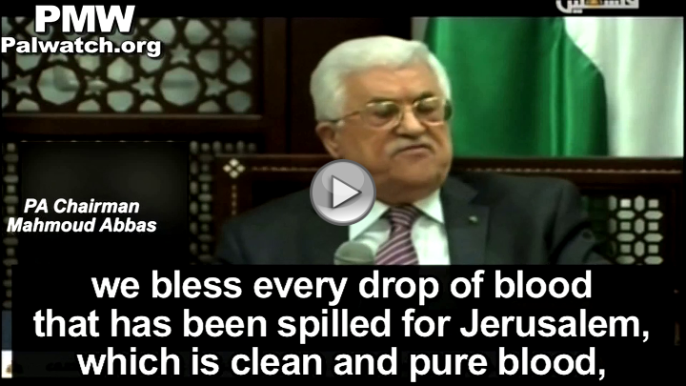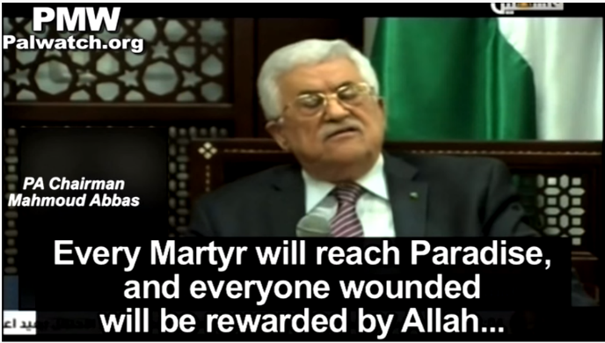
"We bless every drop of blood that has been spilled for Jerusalem, which is clean and pure blood, blood spilled for Allah, Allah willing. Every Martyr (Shahid) will reach Paradise, and everyone wounded will be rewarded by Allah. The Al-Aqsa [Mosque] is ours... and they have no right to defile it with their filthy feet. We will not allow them to, and we will do everything in our power to protect Jerusalem."
[Official PA TV, Sept. 16, 2015
and official website of PA Chairman Abbas, Sept. 16, 2015]
Similarly, while Abbas and the PA claim to combat terrorism in all its forms, when referring to Palestinian terrorism against Israelis, Abbas claims that these acts are merely a “popular uprising”. Speaking after a wave of terror attacks that started at the beginning of October 2015 when a 17-year-old Palestinian terrorist (Muhannad Halabi) murdered two Israelis (Nehemiah Lavi and Aharon Bennet) and injured others, Abbas claims that these acts are simply a “peaceful popular uprising”:
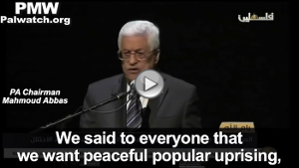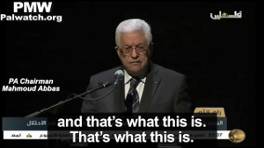
Abbas: “No one called for this uprising and no one asked for it. It stemmed from the hearts of the young... We said to everyone that we want peaceful popular uprising, and that’s what this is. That’s what this is.”
[Official PA TV, Nov. 16, 2015]
According to Abbas and his PA that combat terrorism, when Palestinians kill young Israeli parents in front of their children, kill Israeli teens, or kill Israeli fathers with their sons, it is not to be condemned as terror because it is an expression of “peace.”
The following is the full text of Abbas’ speech, as broadcast on official PA TV. The sections highlighted are those in which Abbas diverted from the written text:
Official PA TV, speech by PA Chairman Mahmoud Abbas on May 19, 2020
In light of the provisions of the Israeli government coalition agreement, which stated that “the Prime Minister will be able to bring the agreement that was reached with the United States on applying Israeli sovereignty starting on 1 July 2020 to the Cabinet and the Knesset,” and the speech of the Prime Minister of the Israeli occupation government at the Knesset the day before yesterday, which was devoid of any commitment to the signed agreements, declaring instead the application of Israeli sovereignty on the Israeli colonies in the Palestinian territories;
The Prime Minister of the occupation government reiterated this declaration in his first cabinet meeting, considering annexation a priority to this government, which means annexing parts of the territory of the state of Palestine to the occupation state based on the so-called "deal of the century", that we reject in its totality. This would entail the annulment by the occupying authority of the Oslo Accords and all other agreements concluded with it, after years of disregard for all these agreements and all UN resolutions and international law;
Following the US administration’s recognition of Jerusalem as capital of Israel, moving its embassy there, then its publication of the so-called "deal of the century", which set the base for the Israeli annexation declaration, which constitutes a grave breach of UN resolutions and international law, as well as this administrations support to Israeli settlements and Israel’s colonial occupation of the territory of the state of Palestine;
Given our unshakeable faith in, and our firm commitment to the right of our people to, pursue their national struggle to end occupation and achieve their independent, contiguous and sovereign state of Palestine on the June 4, 1967 borders with East Jerusalem as its capital, and a solution to the question of refugees in accordance with the, Arab Peace Initiative and the relevant UN resolutions, and release of the Palestinian prisoners from Israeli detention centers and jails;
Given also our commitment to achieve a just and comprehensive peace in fulfillment of the two-state solution, based on the Arab Peace Initiative and the UN resolutions, notably Security Council resolution 1515 which endorses the Arab Peace Initiative, and resolution 2334 that pertain to Jerusalem and settlements, and General Assembly resolution 194 regarding Palestine refugees, as well as General Assembly resolution 67/19 of year 2012, on the membership of the State of Palestine in the United Nations;
Abiding by the decisions of the National Council and the Central Council of the Palestine Liberation Organization, the sole and legitimate representative of the Palestinian people, the Palestinian leadership has today decided the following:
First, the Palestine Liberation Organization and the State of Palestine are absolved, as of today, of all the agreements and understandings with the US and Israeli governments and of all the commitments based on these understandings and agreements, including the security ones;
Second, the Israeli occupying power has to shoulder all responsibilities and obligations before the international community as an occupying power in the territory of the occupied state of Palestine, with all its consequences and repercussions that it entails based on international law and international humanitarian law, particularly the Fourth Geneva Convention of 1949, which holds the occupying power responsible for the protection of the civilian population under occupation and their properties, criminalizes collective punishment, prohibits theft of resources, appropriation and annexation of land, prohibits forced transfer of the population of the occupied territory and the transfer of the population of the occupying power (the settlers) to the land it occupies. All these are grave violations and war crimes.
Third: We hold the US administration fully responsible for the injustice befalling the Palestinian people and we consider it a primary accomplice with the Israeli occupation government in all its hostile and unjust decisions and measures against our people. Yet we welcome the positions of the other US stake holders that reject the policies of this administration that are hostile to our people and their legitimate rights.
(From here, PMW translation from the Arabic as broadcast on official PA TV, was missing in PA submission:)
We have heard many positions from American leaders from Congress and more who reject this policy. We are making a distinction. We are not against America as a people, we are against colonialist America, the America of [US President Donald Trump’s] administration, settlement America, and the America that is hostile to the Palestinian people and the peoples of the world, but [we are] not against the Americans or those who hold American citizenship – we are against those who stand against us.
(End of PMW translation of excluded section)
Fourth: We decide today to pursue signing accession instruments allowing the State of Palestine to join international organizations and conventions that we have not yet joined.
(From here, PMW translation from the Arabic as broadcast on official PA TV, was missing in PA submission:)
There are a number of organizations in which we have ended [our] membership according to an agreement. Currently we are released from the agreement, and we signed on [membership] with some of them yesterday [May 18, 2020]. That’s it.
(End of PMW translation of excluded section)
Fifth: We reaffirm our commitment to UN resolutions and international law, as well as to the resolutions adopted by the League of Arab States, the Organization of Islamic Cooperation and relevant regional organizations to which we are member. We also reiterate our firm commitment to combating international terrorism in all its forms and regardless of its source.
Sixth: We reaffirm our commitment to a solution of the Palestinian-Israeli conflict based on the two-state solution, and our readiness to accept the presence of a third party on the borders between us and Israel, through negotiations that will be held under international auspices (the International Quartet plus) and through an international peace conference on the basis of the UN resolutions and international law. Under extensive international auspices: the international Quartet or the international Quartet plus. But the US by itself – No. We won’t agree to the US [by itself].
Seventh: We call on the countries of the world that have rejected the so-called “deal of the century,” and US and Israeli policies and measures that violate UN resolutions, international law and the signed agreements, to not only reject and condemn
(From here, PMW translation from the Arabic as broadcast on official PA TV, was missing in PA submission:)
– how easy it is [to express] opposition and condemnation and fulfill one’s obligation There are a lot of people on our side [in the Arab states] who say we will condemn and that is enough – …
(End of PMW translation of excluded section)
but also adopt positions to deter such actions and to impose serious sanctions to prevent the occupying Power from implementing its plans,
(From here, PMW translation from the Arabic as broadcast on official PA TV, was missing in PA submission:)
Because [many states] say that they oppose, but in the meantime Israel is annexing. Is this legal? [They say:] ‘No, it is illegal.’ It is not enough to say it is illegal.
[They must say to Israel:] ‘It is illegal and a crime and we will impose sanctions on you.’ This is how it should be, and this is what we are demanding of all the world states, whom we thank for their position of opposition, but we are not making do with opposition
(End of PMW translation of excluded section)
and continuing its denial of the rights of our people. We also call on the countries that have not yet recognized the State of Palestine to do so promptly to preserve the prospect of peace and to uphold UN resolutions and international law. We further call for the implementation of Security Council resolutions on providing international protection to our people in their occupied state.
(From here, PMW translation from the Arabic as broadcast on official PA TV, was missing in PA submission:)
There are those who say: ‘We do not want to recognize [a Palestinian state] because that is a unilateral decision.’ Do you recognize the State of Israel? Yes. Is Israel attacking us? Yes. Then recognize us. Recognize us. Why don’t you want to recognize us? Who is pressuring you not to recognize us? …
(End of PMW translation of excluded section)
We will continue pursuing accountability for the crimes committed against our people by the Israeli occupation before all international institutions and courts. In this context, we stress our trust in the independence and credibility of the International Criminal Court.
Eighth: We salute once again our people, in Palestine and in the diaspora, for their resilience, steadfastness, struggle and for their embrace of the PLO, the sole and legitimate representative of the Palestinian people. We pledge to our honoured martyrs, our brave prisoners
(From here, PMW translation from the Arabic as broadcast on official PA TV was missing in PA submission:)
Currently, [the Israelis] have asked the banks not to pay the prisoners. We will pay the prisoners, and let [the Israelis] just try to stop us (literally: “against the will of their father” –Ed.)
(End of PMW translation of excluded section)
and wounded that we will remain faithful to our oath until victory, freedom, independence and return are achieved, and till we raise together the Palestinian flag over the Al-Aqsa Mosque and the Church of the Holy Sepulcher in our Jerusalem, the eternal capital of our Palestinian state.”
[Official PA TV, May 19, 2020]
The following is the text of Abbas’ speech as submitted by the PA to the ICC:
