Tweet by U.S. Ambassador to the U.N. Human Rights Council Regarding the U.N. “Commission of Inquiry” on Israel

July 28, 2022
https://twitter.com/USAmbHRC/status/1552563133335601154

Ambassador Michèle Taylor

@USAmbHRC

We are outraged by recent antisemitic, anti-Israel comments made by a member of the Israel COI. These unacceptable remarks sadly exacerbate our deep concerns about the open-ended nature & overly broad scope of the COI and the HRC’s disproportionate & biased treatment of Israel.

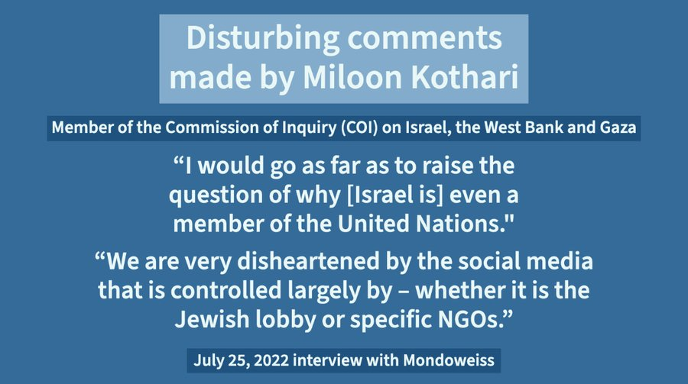

12:54 AM · Jul 28, 2022

Ambassador Michèle Taylor

@USAmbHRC

·
9h
Replying to
@USAmbHRC
As we have stated repeatedly, we firmly oppose the open-ended and vaguely defined nature of the
@UN_HRC
’s Commission of Inquiry on the situation in Israel and the West Bank and Gaza. This one-sided, biased approach to Israel does nothing to advance the prospects for peace.

