Palestinians carry the body of Rashed al-Omary during his funeral in the West Bank village of Silat el-Harithiya
August 7, 2008
Townhall.com
http://townhall.com/photos/2006/08/07/palestinians_carry_the_body_of_rashed_al-omary_during_his_funeral_in_the_west_bank_village_of_silat_el-harithiya

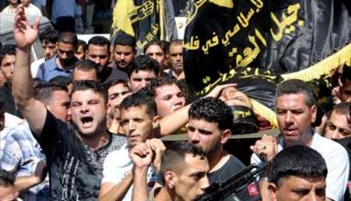

Palestinians carry the body of Islamic Jihad militant Rashed al-Omary during his funeral in the West Bank village of Silat el-Harithiya near Jenin August 7, 2006. Israeli forces killed a wanted Palestinian gunman near the northern West Bank town of Jenin on Sunday, a spokesman for the Islamic Jihad militant group said. An Israeli army spokeswoman said the gunman was shot dead after troops came under fire during an arrest raid. REUTERS/Mohamad Torokman (PALESTINIAN TERRITORIES)

