Two IDF soldiers killed in Samaria terror attack

February 4, 2025

By [**Joshua Marks**](https://www.jns.org/writers/joshua-marks/)**,**[**Akiva Van Koningsveld**](https://www.jns.org/writers/akiva-van-koningsveld/)

Jewish News Syndicate

<https://www.jns.org/eight-wounded-two-critically-in-terrorist-attack-in-northern-samaria/>

Two Israel Defense Forces soldiers were killed and eight more were wounded when a terrorist opened fire at a military post near the village of Tayasir in northern Samaria on Tuesday morning.

The slain troops were identified by the military as IDF Sgt. Maj. (res.) Ofer Yung, 39, a squad commander in the Ephraim Regional Brigade’s 8211th Reserve Battalion, from Tel Aviv, and Sgt. Maj. (res.) Avraham Tzvi Tzivka Friedman, 43, a soldier in the battalion, from Ein Hanatziv.

According to an initial IDF probe, the terrorist managed to take up a position near the entrance of the military post and fired on troops as they exited. The terrorist was said to have exchanged fire with troops inside the post for several minutes before being killed.

The terrorist, who reportedly had been waiting in the area for hours before carrying out the attack, was said to have been armed with an M-16 rifle and two magazines, and was wearing a tactical vest.

According to the IDF, two of the wounded soldiers were listed as being in serious condition, while the other six victims sustained light wounds.

The [death toll](https://www.idf.il/%d7%90%d7%aa%d7%a8%d7%99-%d7%99%d7%97%d7%99%d7%93%d7%95%d7%aa/%d7%99%d7%95%d7%9e%d7%9f-%d7%94%d7%9e%d7%9c%d7%97%d7%9e%d7%94/%d7%97%d7%9c%d7%9c%d7%99-%d7%95%d7%a4%d7%a6%d7%95%d7%a2%d7%99-%d7%a6%d7%94-%d7%9c-%d7%91%d7%9e%d7%9c%d7%97%d7%9e%d7%94/) among Israeli troops on all fronts since the Hamas-led terror attacks in southern Israel on Oct. 7, 2023 now stands at 844.

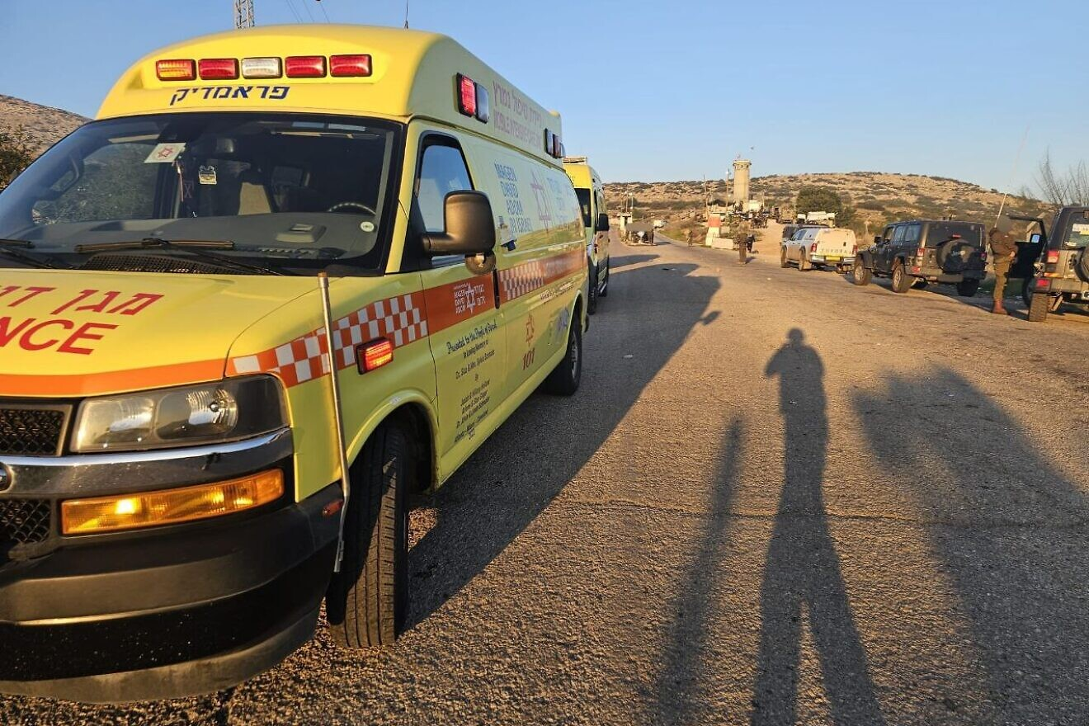A Magen David Adom emergency medical service ambulance at the scene of a terrorist attack at an Israeli military post in northern Samaria on Feb. 4, 2025. Credit: MDA.

The village of Tayasir is located near Tammun, an area where Israeli forces have been conducting a major counter-terrorism operation since Jan. 31, dubbed “Operation Iron Wall.”

On Thursday, IDF Staff Sgt. Liam Hazi, 20, of the Kfir Brigade’s Haruv reconnaissance unit became the operation’s first casualty. Hazi was killed in a firefight with terrorists in Jenin, the military said.

The IDF [expanded](https://www.jns.org/idf-expands-northern-samaria-operation-forms-new-jenin-battalion/) the operation on Monday and plans to form a new battalion that will remain in northern Samaria once the operation ends.

The IDF has killed more than 50 [Palestinian terrorists](https://www.jns.org/idf-50-terrorists-killed-100-detained-since-start-of-samaria-op/) since the start of the operation on Jan. 21, the military announced on Sunday evening.

At least 35 gunmen were killed during ground operations in the Jenin and Tulkarem areas, while another 15 were killed in airstrikes, according to the IDF. More than 100 wanted terrorists have been detained thus far.

Israeli forces “located and confiscated dozens of weapons, destroyed hundreds of explosive devices and dozens of additional charges that were planted on roads to harm our forces,” the military stated.

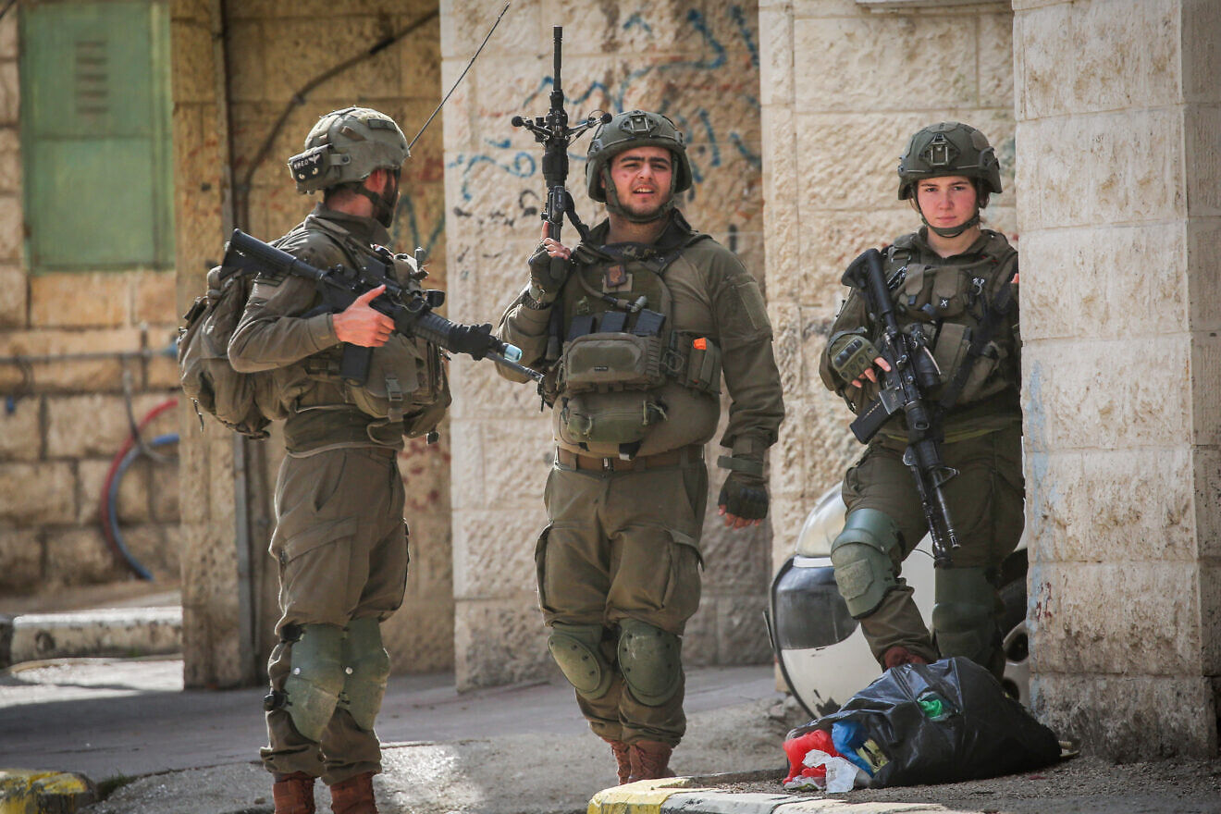Israeli security forces seen during a military operation in the Samaria city of Jenin, Feb. 1, 2025. Photo by Nasser Ishtayeh/Flash90.

On Sunday, the operation was expanded to include Tammun near Nablus. On Jan. 20, one IDF soldier was killed and four others were wounded when their vehicle was hit by a [roadside bomb](https://www.jns.org/idf-soldier-killed-by-roadside-bomb-in-northern-samaria/) in the town.

Earlier on Sunday, the army said it had destroyed “several buildings in Jenin, in the Menashe Brigade [area of responsibility], which were used as terror infrastructure.”

According to the IDF, security forces destroyed 23 structures in the Jenin area where terrorist infrastructure was located after searching hundreds of buildings in the vicinity. During the sweeps, explosives laboratories, weapons, observation posts and more terror infrastructure was found.

The head of the Jordan Valley Regional Council, David Elhayani, said on the *Kan Reshet Bet* radio station after Tuesday’s attack that he believes the ongoing military operation in northern Samaria is not enough.

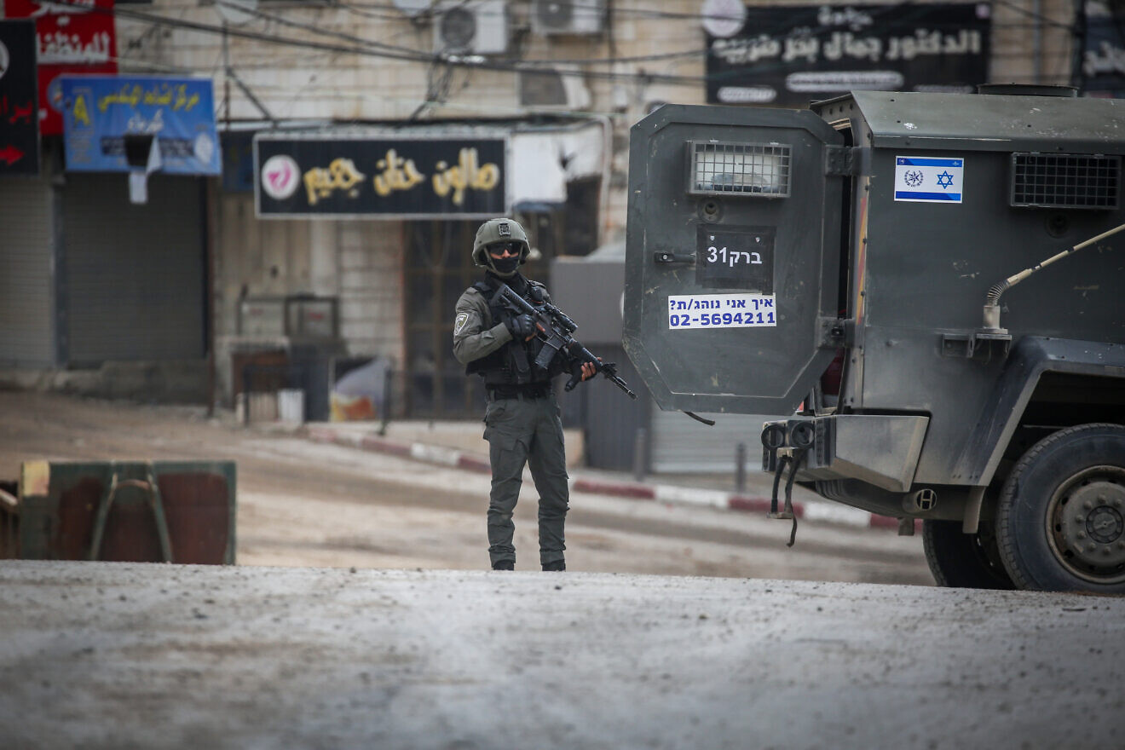Israeli security forces seen during a military operation in the Samaria city of Jenin, Feb. 1, 2025. Photo by Nasser Ishtayeh/Flash90.

“Anyone who is under the illusion that tomorrow morning, as a result of one operation or another, there will be no more attacks is deceiving themselves and does not understand the reality we live in,” charged Elhayani. “The army is carrying out intense activities and operations unlike anything seen before, but this operation needs to be expanded.”

In a statement released in response to the attack, the Yesha Council of Juduea and Samaria communities expressed support for IDF troops and their commanders, praising their efforts to defend Israeli citizens.

“The determined fighting of our heroic warriors pushes the evil terrorists away from the homes of Israeli citizens and prevents scenes similar to those of Oct. 7 from occurring in places like Afula and Netanya, God forbid,” said the council.

“This morning’s attack once again proves that Arab terrorism seeks to harm the State of Israel and IDF soldiers,” the statement continued. “The Israeli government has a duty to decisively defeat Arab terrorism and to announce the application of Israeli sovereignty, which will prevent the establishment of a terror state in the heart of the country.”