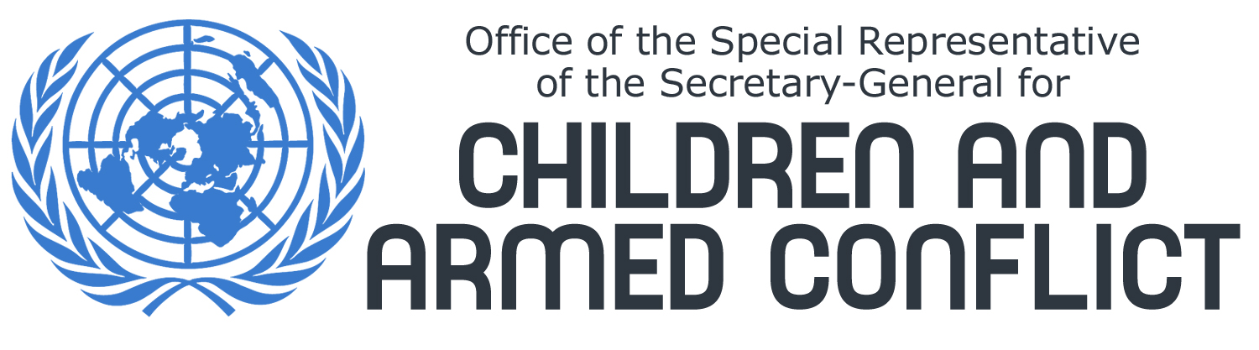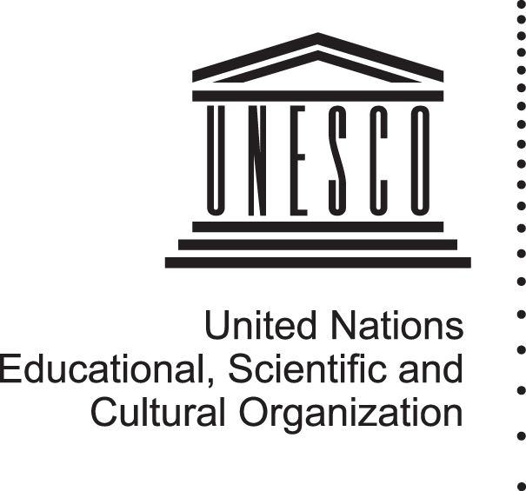

UNESCO Director- General and UN Special Representative of the Secretary-General for Children and Armed Conflict express grave concern over attacks against Gaza UNRWA schools

Paris/New York 7 January – UNESCO Director-General Koïchiro Matsuura and UN Special Representative of the Secretary-General for Children and Armed Conflict, Radhika Coomaraswamy, expressed grave concern over the recent attacks against UNRWA schools and associated facilities. These facilities had been set up by the UN as places of refuge for civilians fleeing the fighting in Gaza.

Their statement follows the shelling by Israeli military of three schools operated by the United Nations Relief and Works Agency for Palestinian Refugees in the Near East (UNRWA). A large number of civilians, including children were killed, particularly in the third strike, and many more were injured.

“These attacks are extremely distressing. I reiterate that schools should, in no way, be involved in military conflict”, said Mr. Matsuura. “Schools must remain zones of peace and security in all circumstances,” he added.

“All parties should agree to a ceasefire for the sake of the children and the civilian population which bear the brunt of the conflict”, stated Ms. Coomaraswamy. The Special Representative reiterated her call to Hamas to stop its indiscriminate rocket fire. She also urged the Government of Israel to take all necessary measures to limit civilian casualties and to investigate into its military strikes against schools. “Something went terribly wrong and those who committed these attacks must be held responsible,” she added.

Mr. Matsuura and Ms. Coomaraswamy joined their voice to the call made on 6 January to the Security Council by the United Nations Secretary - General: “These attacks by Israeli military forces which endanger UN facilities acting as places of refuge are totally unacceptable, and should not be repeated. Equally unacceptable are any actions by Hamas militants which endanger the Palestinian civilian population. [These] events underscore the dangers inherent in the continuation and escalation of this conflict,” stated Mr. Ban Ki-moon.

For further information, please contact:
Ms. Laurence Gérard, Communications Officer, Office of the Special Representative of the Secretary-General for Children and Armed Conflict. Phone: +1 1212-963-0984 gerardl@un.org - www.un.org/children/conflict
Suzanne Bilello, UNESCO New York, Senior Public Information and Liaison Officer – Phone: +1 212-963-4386 – bilello@un.org – www.unesco.org

