Check against delivery

Human Rights Council 25th Session
High-Level Segment

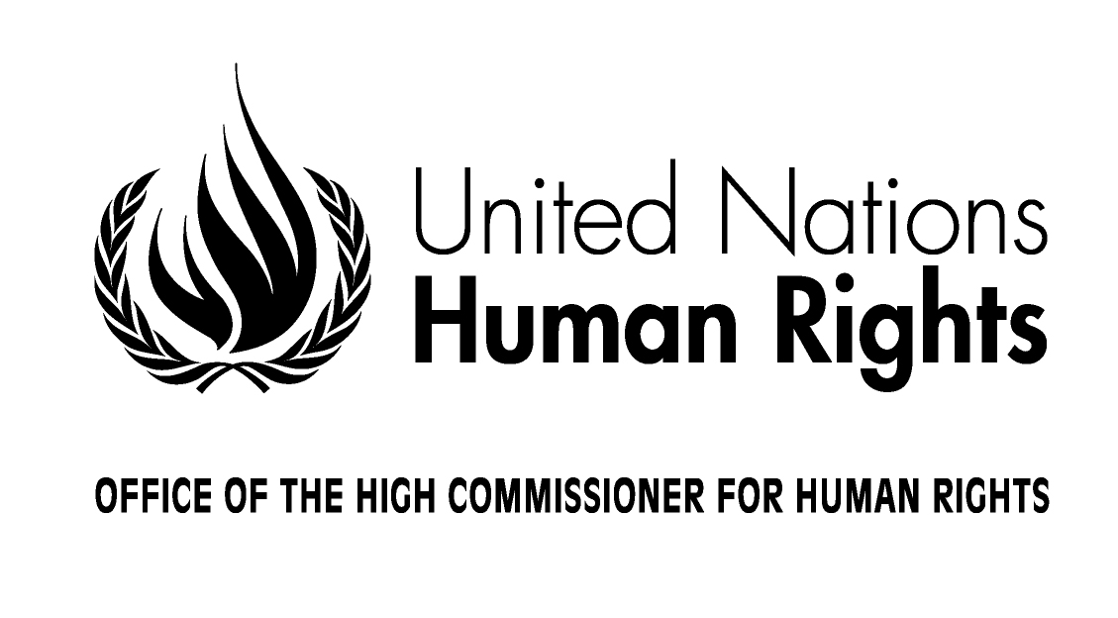

Opening Statement by

Ms. Navi Pillay
United Nations High Commissioner for Human Rights

Geneva, 3 March, 2014
Your Excellency, Mr. Didier Burkhalter, President of the Swiss Confederation,
Your Excellency, Mr. John Ashe, President of General Assembly,
Your Excellency, Mr. Baudelaire Ndong Ella, President of the Human Rights Council,
Mr. Secretary-General,
Excellencies,
Ladies and gentlemen,

Today I address this High-Level Segment of the Council for the last time as High Commissioner for Human Rights. I do so acknowledging the many achievements of the Human Rights Council.
The significance of this Council’s work is reflected in the fact that up to 100 Ministers will participate in this Council’s session. We are particularly honoured today by the presence of the President of Tunisia, whom I wish to warmly welcome.
This 25th Session of the Human Rights Council launches an ambitious year of activities to promote and protect human rights of all people everywhere and strengthen human rights mechanisms in all countries.
I congratulate the new Council President Baudelaire Ndong Ella and the Bureau of the Eighth Cycle on their nomination and wish them much energy and success in their work.
Excellencies, Ladies and Gentlemen,
This Council has accomplished much in a world which cries out for respect for human rights daily. The challenges we face and which we must plan for are at times daunting – discrimination in all its forms, civil strife which can lead to crimes against humanity and war crimes, the development of new technologies – such as drones and lethal autonomous robots - which push us to the outer edge of our thinking on how to ensure our rights are protected, social media and new information technology which raises the question of where the public and private space lies and the importance of on-line and off-line freedoms, and the environmental degradation which affects not only economic and social rights but also impacts on the civil, cultural and political rights.
This Council is meeting many of these challenges through its various mechanisms and tools addressing thematic issues, crisis or chronic situations.
The Universal Periodic Review with its 100 per cent participation by States and the Special Procedures address an ever increasing range of crucial human rights issues and situations.
Commissions of Inquiry have highlighted massive, egregious violations which demand international engagement including by the Security Council and the International Criminal Court.
The Council’s mechanisms can also contribute to the new, landmark initiative of the Secretary-General, Rights up Front. This initiative places preventive action to ensure respect for human rights at the core of the UN, to avoid future conflict.
Human rights violations are often the first tremors on the ground, that can signal potential larger scale violence.
For this reason, the Security Council’s recent more active approach to human rights should be sustained. It reflects States’ recognition of the intrinsic link of peace, security and the enjoyment of human rights. UN peace-keeping missions now routinely include robust human rights mandates.
Development must also be part of the human rights equation, including in relation to conflict prevention. In this regard, this Council has consistently encouraged discussion and action to ensure that human rights are part of the post-2015 agenda and the Sustainable Development Goals. UN Country Teams now increasingly have human rights advisors deployed to advise on how to promote and protect the full range of human rights for all.
Mr. President
The General Assembly’s 3rd Committee adopted only a few weeks ago, a ground-breaking resolution that improves the architecture of the treaty body system. I applaud this outcome – years in the making – and the efforts of all those who worked so hard in finding common ground.
Excellencies,
Streets, airwaves, entire countries are buzzing with demands for economic, social and political justice. More and more, people are confidently laying claim to their rights. This Council has given space to them and the civil society that represents them in its deliberations, panels, and side events.
Vigilance however is important. While we must continue to ensure civil society engagement at the international level, this is no guarantor that it will be complemented at the national level. We need to work together to ensure that the space, voice and knowledge of civil society is nurtured in all our countries.
The UN itself is required to protect and support those who contribute to its work, often at great personal risk.
That is why I remain very disturbed of reports of reprisals against persons who co-operate with United Nations human rights representatives and mechanisms.
This Council, the Secretary-General and I have taken an uncompromising view of these intolerable incidents. I commend the fact that the Council adopted a forward looking resolution on this issue during its last session. I ask for your support to ensure that this is followed through at the General Assembly.
Mr. President,
At the core of my mandate and this Council’s work is combatting discrimination in all its forms.
Intolerance of “the other” adversely affects the enjoyment of rights by indigenous peoples, migrants, minorities, LGBT and other marginalized persons.
In this regard, full implementation of the Durban Declaration and Programme of Action and Outcome Document, as affirmed by the Durban Review Conference, is no less important today than it was in 2001. My Office is already promoting the implementation of many of its recommendations through our 58 field presences.
Excellencies,
Looking ahead, I see that much is left undone, and daunting challenges lie ahead for the full protection and promotion of human rights.
In many parts of the world impunity is still rampant, and accountability based on the rule of law remains a dream.
Physical or sexual violence continues to affect more than one third of all women. More than one in three women aged between 29 and 49 around the world today were married under the age of 18 years. Hundreds of thousands of cases of maternal mortality due to preventable causes occur every year. Millions of children still face a life of exploitation, neglect and poverty.
In addressing all these matters, the research and advocacy of my Office and the wider UN, the robustness of the international human rights mechanisms and the energy and vision of the Human Rights Council all have vital roles to play, but need the necessary resources to do so.
Early this year, I initiated a Functional Review of my entire Office. This is to ensure that we stay abreast of change and most effectively fulfil our vital mandate, now and in the years ahead.
We are controlling costs, seeking resource-efficiency and further building a culture of results into the organization.
Excellencies,
Despite the challenges, attention to human rights is going from strength to strength. One cannot read a newspaper, a blog, or switch on a channel without hearing about human rights.
Those who ignore these voices often find themselves being called to account – sooner or later –and lose their power.
Respect for human rights is not a mere legal obligation but also bestows legitimacy on those leaders who ensure this respect.
This was clear to the “we the peoples of the United Nations” nearly 70 years ago who determined, and I quote:
“to save succeeding generations from the scourge of war…; reaffirm faith in fundamental human rights, in the dignity and worth of the human person…; establish conditions under which justice and respect for the obligations arising from treaties and other sources of international law can be maintained; and to promote social progress and better standards of life in larger freedom. “
The protection of human rights is at the very heart of the United Nations. It must shine through the decisions of its intergovernmental bodies and throughout the work of the Organization.
I wish you a successful session. Thank you for your attention.

