Check against delivery

Human Rights Council 25th Session

Item 2 – High Commissioner’s Annual Report

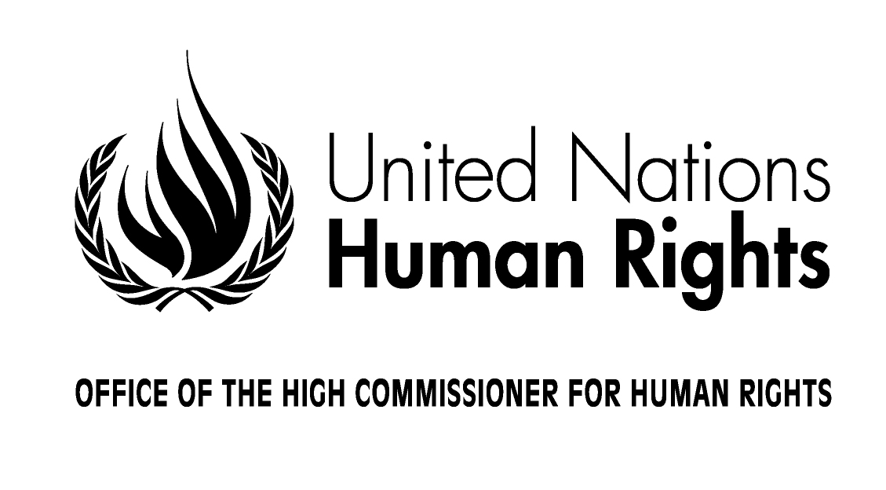

Opening Statement by
Ms. Navi Pillay
United Nations High Commissioner for Human Rights

Geneva, 6 March 2014

Mr. President,
Distinguished Members of the Human Rights Council,
Excellencies,
Colleagues and friends,

2013 was a landmark year for OHCHR. The twentieth anniversaries of the Vienna Declaration and the establishment of the High Commissioner's mandate gave us an important opportunity to re-emphasize the universality, indivisibility and interdependence of human rights. They reminded us that you entrusted the High Commissioner with the responsibility of speaking out against discrimination, tyranny and disregard for fundamental values which rob our fellow human beings of their rights to live as equals, in dignity, free from fear and want.

Today the task of protecting and promoting human rights is as vital as it was twenty years ago. It has been my privilege to guide the work of this Office as it has sought to confront many human rights crises and new threats to the rights and dignity of individuals. With the help of OHCHR, the concepts and vocabulary of human rights have grown more inclusive. They are now more strongly advocated by civil society and have increasingly become central to peace and security, development and humanitarian action.

I will highlight key aspects of my Annual Report and issues that have risen to prominence more recently.

Engaging the United Nations system

One of the most notable developments during my term has been the strong reaffirmation of human rights as one of the three pillars of the United Nations system, together with peace and security, and development. The report of the Secretary-General’s Internal Review Panel on United Nations action in Sri Lanka, as well as the United Nations System Chief Executives Board for Coordination reaffirmed this bedrock foundation: The Secretary-General's "Rights Up Front" plan of action contains critical recommendations for the whole system to be more responsive in preventing and addressing human rights violations. OHCHR is committed to ensuring follow-up to the Plan of Action, which, if sincerely and collectively implemented, will contribute very significantly to promoting peace and security and development around the world.

Becoming more operational

In another key step forward in recent years, countries have become more open to engaging with OHCHR and seeking our assistance. This is reflected in the expansion of our field presences. Today we support 58 field presences, including 13 country/stand-alone offices, 14 human rights components of peacekeeping missions and special political missions, 12 regional offices and centres, and 19 human rights advisers operating with United Nations Resident Coordinators and country teams. OHCHR is discussing the terms for opening a regional office for North Africa in Cairo, and a country office in Myanmar. These presences provide national authorities and stakeholders with direct and targeted assistance in addressing human rights issues.

Our work in 2013 was grounded in a long-term vision for the realization of six thematic priorities:

- ending discrimination;
- fighting impunity and working to ensure a stronger rule of law and responsive democracies;
- combating poverty and promoting progress towards economic, social and cultural rights;
- protecting and promoting the rights of migrants;
- confronting violence and insecurity;
- and constantly improving the efficacy and impact of human rights mechanisms and international law.

Discrimination

Excellencies, discrimination is a severe attack on the universality of human rights. The exclusion, marginalization and abuse of people on the basis of their perceived race, their indigenous, ethnic or religious background, their colour, gender, caste status, disability, age, health status, or sexual orientation, are scourges that my Office is determined to combat.

As part of our effort to counter national, racial or religious hatred in the form of incitement to discrimination, hostility or violence, my Office helped to create a detailed body of guidance known as the Rabat Plan of Action. While maintaining the norm of free speech, this clarifies the kinds of speech and acts that international law obliges us to prohibit, and recommends a number of actions for various stakeholders. OHCHR also worked with sports bodies to sensitize the public on the eradication of racism in sport, a symbolically important issue.

Another initiative that I am pleased to highlight is my Office's effort to create a database on practical means to combat racism, racial discrimination, xenophobia and related intolerance. This tool contains more than 1,500 documents and information from more than 90 countries. It is intended to provide States with advice on policies and programmes to eradicate racial discrimination and to promote equality.

Nonetheless, it has been painful to observe in the past year that in a number of European countries Roma continue to be victims of social exclusion and segregation. Our efforts to redress this situation in several countries have included, for example, support for efforts to set up an equality body in the Republic of Moldova, and assistance to the national human rights institution in challenging discriminatory laws and separate schooling.

Throughout my time as High Commissioner, OHCHR has forthrightly sought to address discrimination against women and girls. In 2013, together with UN-Women and the United Nations Development Programme, OHCHR developed a global programme to increase women’s access to justice through law and justice reforms. We have also recently concluded a framework for cooperation with UNFPA, for work in a number of areas, including sexual and reproductive rights.

With regard to sexual violence, OHCHR has been firm, clear and practical. In 2013, assessment missions to the Central African Republic, Colombia, the Democratic Republic of the Congo and Somalia made recommendations to strengthen these countries’ legal and institutional structures regarding sexual violence in conflict. In the Democratic Republic of the Congo, the United Nations Joint Human Rights Office supported mobile courts to deal with cases of sexual violence, and provided military prosecutors with technical support to investigate sexual violence and other serious violations in remote areas of the country. OHCHR also supported efforts in Afghanistan, Guinea-Bissau and Sierra Leone to address sexual and gender-based violence.

Older persons are often subjected to discrimination, marginalization and abuse. Over the past year OHCHR has supported and organized several significant meetings to strengthen the protection of their human rights. I am encouraged by the decision of the Council to appoint a special procedures mandate holder at this Session, and am hopeful that the age discrimination gap in the international normative framework will also soon be filled through the work of this Council, and of the working group on the human rights or older persons in New York.

In the past five years, there has been growing awareness of the severity and extent of human rights violations based on sexual orientation. In July 2013, OHCHR launched "Free & Equal", a global campaign designed to raise awareness of this form of discrimination and violence against lesbian, gay, bisexual and transgender persons. In the six months since it was launched, millions of people have accessed and shared campaign videos, factsheets and other materials.

Impunity and the rule of law

Strengthening the administration of justice remains a priority for OHCHR, with focuses on such fundamental issues as the independence of the judiciary and the protection of the rights of persons deprived of their liberty. We continue to support human rights mechanisms that specifically address these issues. My Office has also continued its advocacy in favour of a moratorium on the death penalty, with the goal of its complete abolition. I am heartened to note that the list of countries which have abolished this cruel measure, or adopted a moratorium, is growing constantly.

OHCHR also continues to support a robust and comprehensive approach to strengthen accountability and to fight impunity for gross human rights violations. In 2013 we accompanied national efforts in drafting transitional justice laws in Libya, Tunisia and Yemen, among others. We supported inclusive and participatory approaches to transitional justice processes in Côte d’Ivoire, Tunisia and Guinea. I welcome the recent judgement of the Supreme Court of Nepal, which ruled out amnesty provisions and directed the Government to revise legislation for transitional justice mechanisms that comply with international standards.

Nearly five years on from the end of the conflict in Sri Lanka, I regret that the Government has failed to satisfy the Council’s call for a credible and independent investigation into allegations of serious human rights violations. I therefore recommend that the time has come for the Council to establish its own international inquiry mechanism which I believe can play a positive role where domestic mechanisms have failed.

I have also repeatedly called for an immediate, comprehensive and independent investigation into all human rights violations that have taken place in recent months in Ukraine, including killings, disappearances, arbitrary detentions, torture and ill-treatment. I strongly believe that respect for human rights norms and standards, building a society that is inclusive of the rights of all, is key to finding a peaceful and durable solution to the current crisis. In this regard, I would like to inform you that Ivan Simonovic, Assistant Secretary General for Human Rights, travelled today to Ukraine and other staff from the Office shall travel over the weekend.

Victims of human rights abuses in war, armed conflict and foreign occupation must be assisted to achieve justice and recover their integrity. In 2013, together with UN-Women, we finalized a guidance note on reparations for victims of sexual violence. We also launched a study on reparations for survivors of sexual violence in Kosovo.

Civilians are increasingly targets during armed conflict, and protecting them is a vital part of peacekeeping missions. This requires timely and well-resourced human rights monitoring, advocacy and reporting. My Office has cooperated with DPKO and DPA to develop a joint policy that seeks to ensure that that all parts of the mission will work better together to respond to the risk of human rights violations, including in situations of imminent physical violence against civilians. We have also advised on preventive deployments and contingency plans, and the shelter and escort of civilians and have worked with local communities to provide alerts on risks of human rights violations.

Protecting human rights in the context of counter-terrorism has continued to be problematic, as with the failure to close the United States’ Guantanamo Bay detention facility. In Egypt, where the Government is launching what it describes as a counter terrorism campaign, it is important that human rights are respected; in particular, protection from arbitrary detention, fair trial, and freedom of expression and peaceful assembly. My Office stands ready to assist.

Armed drone strikes have also raised deep concern, particularly regarding transparency, accountability and redress for victims. My Rule of Law colleagues and the Special Rapporteurs on Extrajudicial, summary and arbitrary executions, and on protection of human rights while countering terrorism, are addressing this topic.

Poverty and the right to development

OHCHR continued to advocate for a human rights-based approach to development, and for a post-2015 development framework that addresses both freedom from fear and freedom from want for all. We pursued these objectives through research, expert meetings, consultations, advocacy and public events, as well as via development of methodologies and selection criteria for post-2015 goals, targets and indicators. Consequently, in 2013, I am pleased to report that the value and centrality of human rights have been recognized in each of the key milestones in the Post-2015 process so far.

It is also a pleasure to highlight our landmark publication, "Realizing the Right to Development”. In addition we launched a guide to improving assessment of the impact of human rights policies and development programmes via key indicators.

Mainstreaming human rights into United Nations development policies and operations is a core element of my mandate. In 2013 OHCHR led a number of important inter-agency efforts to integrate human rights more solidly into the development agenda, and this work has generated considerable interest. Notably, the Deputy-High Commissioner is now the Vice-Chair of the UN Development Group and Chair of its Human Rights Mechanism. OHCHR also co-chairs the Working Group on the Resident Co-ordinator System. This year, as a result of this work, a new Job Description for UN Resident Coordinators was adopted, fully integrating human rights functions and accountabilities.

Migrants

Over the past four years, through its engagement in the Global Migration Group, the Global Forum on Migration and Development, and the High-Level Dialogue of the General Assembly, OHCHR has advanced a strong human rights approach to migration. In addition to producing an analytical report entitled Migration and Human Rights: Improving human rights-based governance of international migration, OHCHR also increasingly engaged in migration-related work through its field presences.

I am deeply distressed by the many boat tragedies off the coasts of Greece, Italy, Malta, and Spain, and I call on the authorities to strengthen systems to protect against such events. As we have heard, UNHCR estimates that 73 percent of the migrants arriving in Italy meet the legal criteria for refugee status, and it is important that they have access to the proper asylum procedures. I must emphasize that persons seeking international protection in the territorial sea or at maritime borders must be treated in the same way as those who apply for protection on land. Clearly much more needs to be done to protect the human rights of migrants in this region.

Recent violence in the Regional Processing Centre on Manus Island, Papua New Guinea, has underscored the need to review the Regional Resettlement Arrangements signed by Australia with Papua New Guinea and Nauru, to ensure that the human rights of migrants and asylum seekers are fully protected in accordance with international law.

Violence and insecurity

In addition to our work to anchor the protection of civilians at the core of United Nations peace missions, OHCHR continued to address human rights violations in situations of conflict. Despite this Council's forthright calls for full access for the Commission of Inquiry to Syria, the Commission has remained unable to visit the country, though data is being collected from neighbouring countries regarding human rights violations committed in the context of the conflict.

OHCHR has also supported the Commission of Inquiry and fact-finding mission to investigate allegations of widespread and severe human rights violations committed in the Democratic People’s Republic of Korea. Although this mission was not permitted to enter the country, through innovative data-collection the Commission of Inquiry revealed unspeakable violations. It seems to me no State could fail to accept that there must be a stop to these violations, with redress for the victims and accountability for violators.

Over the past 20 years, OHCHR has assisted almost 40 Commissions of Inquiry and fact-finding missions. In order that all stakeholders might fully benefit from this wealth of experience, in 2013 we issued a publication containing guidance on and practice in international Commissions of Inquiry and fact-finding missions The most recent being the Commission of Inquiry on the Central African Republic as established by the Security Council.

Human rights cannot be neglected in humanitarian crises. Many OHCHR field presences are actively engaged in supporting humanitarian coordinators and country teams. In November, OHCHR sent a team to the Philippines to support the United Nations Humanitarian country team in the aftermath of typhoon Yolanda.

Human rights mechanisms

This Human Rights Council's Universal Periodic Review has continued to attract universal participation. I am delighted to note that by November, all 42 States due to be reviewed in 2013 had undergone the process. Several States also reported on recommendations that they had not initially supported during the previous review, a practice that should be encouraged.

Requests to OHCHR to provide information, advice, technical cooperation and other forms of assistance in follow-up to the UPR have grown steadily. In addition, my Office supported 51 special procedures mandates, whose holders give a voice to victims and to the concerns of civil society. They also perform important work in translating international human rights standards into operational guidance tools in specific sectors, for example the Guiding Principles on Security of Tenure of the Urban Poor, which the Special Rapporteur on adequate housing has presented to the Council at this session.

The treaty body system is another key element of our human rights architecture. In 2013, as part of the intergovernmental process for strengthening it, OHCHR delivered a comprehensive assessment of its complexity, workload and full cost. I wish to express my satisfaction at the outcome reached a few weeks ago in the General Assembly and to extend congratulations to all stakeholders involved, including the Co-Facilitators. It has been a demonstration of honest self-analysis and transparency on the part of the UN, and also illustrates how crucial operations can be enhanced by sharpening our focus and making the best possible use of available resources. I look forward to final approval of the outcome of that treaty body strengthening process, and the resources to implement it.

Many of you have acknowledged our support service for the work of this Council as it addresses numerous human rights issues, both urgent and chronic. OHCHR also continues to support the development of effective and relevant international norms. During my term as High Commissioner, substantial progress has been registered regarding economic, social and cultural rights. Notably, the Optional Protocol to the International Covenant on Economic, Social and Cultural Rights entered into force in May 2013. This milestone reaffirmed the justiciability of economic, social and cultural rights.

We accomplished much in 2013. The Office Management Plan for 2014-2017 will continue to focus on the themes I have outlined, adding a new priority: widening the democratic space.

Excellencies, colleagues and friends,

This is my final annual report as High Commissioner for Human Rights. I have found this work to be both moving and inspiring. My mandate has seen a number of major accomplishments, grappled with both unexpected and long-lasting challenges, and witnessed some of the most pitiless and implacable brutality that any human being can imagine. OHCHR has continued to build on the advances made since it was established more than 20 years ago, and I am convinced that this has contributed to the realization of equality, dignity and enjoyment of human rights by many.

And yet many around the world continue to suffer grievously, in violation of every legal principle of human dignity and rights. It is my most heartfelt wish that this Council, with the support of my Office, can find a way to galvanize the international community to act decisively to end this burden on the conscience of humankind.

I thank you Mr President.

