**Operation Protective Edge by the Numbers**

Published on: August 5, 2014

<http://www.idfblog.com/blog/2014/08/05/operation-protective-edge-numbers/>

**Everything you need to know about Operation Protective Edge, from destroyed terror tunnels to rocket attacks on Israel. Just the facts.**

The IDF initiated Operation Protective Edge to put an end to the terror attacks emanating from Gaza. In the three weeks leading up to July 8, terrorists fired **250** rockets capable of reaching Israel’s largest population centers and endangering **3.5 million** Israeli lives. More than **half a million** Israelis had less than **60 seconds** to find shelter after hearing a rocket siren. **Tens of thousands** had only **15 seconds**.

[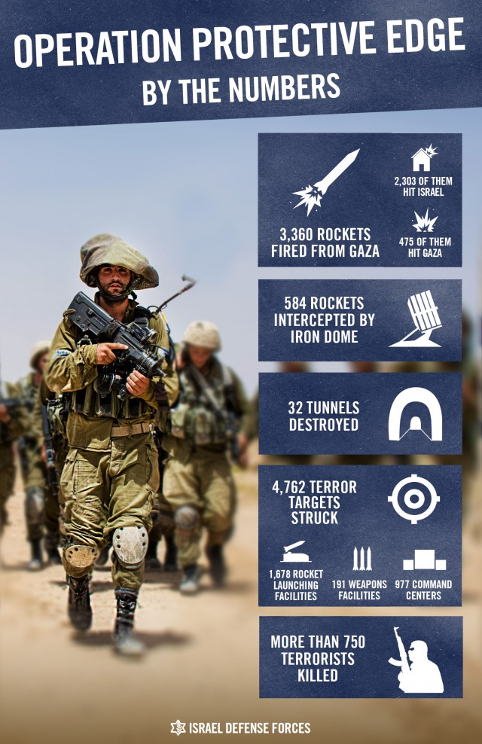](https://web.archive.org/web/20140806021927/http:/www.idfblog.com/wp-content/uploads/2014/08/Sikum-Recap1.jpg)

The Rocket Threat

The IDF initiated Operation Protective Edge in response to[incessant, indiscriminate rocket fire](https://web.archive.org/web/20140806021927/http:/www.idfblog.com/facts-figures/rocket-attacks-toward-israel/) from Gaza directed at Israeli civilians.

Between July 8 and August 6:

* Terrorists in Gaza fired **3,360** rockets at Israel.
* **2,303** rockets hit Israel.
* **115** rockets hit populated areas in Israel.
* **584** rockets were intercepted by Iron Dome.
* **119** rocket launches failed.
* **475** rockets landed within the Gaza Strip.

Before the operation, IDF intelligence assessed that terrorists in Gaza held approximately **10,000** rockets. **1/3** of these rockets were were fired at Israel, and an additional **1/3** were destroyed by IDF forces.

The Tunnel Threat

On July 17, IDF ground troops were [moved into Gaza](https://web.archive.org/web/20140806021927/http:/www.idfblog.com/blog/2014/08/05/first-hand-account-gaza-operation-wounded-idf-soldier/) to locate and destroy the [underground tunnel network](https://web.archive.org/web/20140806021927/http:/www.idfblog.com/blog/2014/07/31/everything-need-know-hamas-underground-city-terror/) used by Hamas to [infiltrate and attack Israel](https://web.archive.org/web/20140806021927/http:/www.idfblog.com/blog/2014/07/17/breaking-idf-thwarts-infiltration-attempt-hamas-terrorists/).

Between July 17 and August 5:

* IDF forces neutralized **32** terror tunnels.
* **14** of these tunnels crossed into Israel.
* **2** tunnels had access points located **300m-500m** from Israel.

Hamas exploited civilian infrastructure

Hamas abuses the civilians and[civilian infrastructure](https://web.archive.org/web/20140806021927/http:/www.idfblog.com/blog/2014/07/28/hamas-uses-hospitals-ambulances-military-purposes/) of Gaza for terrorist purposes. These abuses constitute [severe violations of international law](https://web.archive.org/web/20140806021927/http:/www.idfblog.com/blog/2014/07/22/report-hamas-terror-activity-in-gaza/).

Between July 8 and August 5:

* Terrorists fired **597** rockets from civilian facilities in Gaza.
* Approximately **260** rockets were fired from schools.
* Approximately **160** rockets were fired from religious sites, including mosques.
* Approximately **127** rockets were fired from cemeteries.
* Approximately **50** rockets were fired from hospitals.

IDF struck terror sites throughout Gaza

A primary objective of Operation Protective Edge was to strike a heavy blow to the military capabilities of Hamas and other terrorist organizations in Gaza and thus eliminate the threats to Israel’s national security.

Between July 8 and August 5, IDF aerial, naval and ground forces struck 4,762 terror sites across the Gaza Strip, including:

* **1,678** rocket launching facilities.
* **977** command and control centers.
* **237** military administration facilities.
* **191** weapons storage and manufacturing facilities.
* **144** training and military compounds.
* **1,535** additional terror sites.

From July 8 to August 5, the IDF targeted terrorists in Gaza responsible for the planning and execution of attacks on Israeli soldiers and civilians.

* IDF forces targeted at least 253 Hamas terrorists.
* At least 147 Palestinian Islamic Jihad terrorists.
* At least 65 terrorists of various smaller organizations.
* At least 603 terrorists of unknown affiliation.

In addition, **159** terrorist suspects have been questioned by Israeli security forces.

IDF transferred supplies into Gaza

Despite Hamas’ incessant attacks, including on the Kerem Shalom border crossing, the IDF continued to[transfer thousands of supply trucks](https://web.archive.org/web/20140806021927/http:/youtu.be/KhsjpTWsMh4) into Gaza during Operation Protective Edge.

From July 8 to August 5:

* The IDF transferred **1,856** trucks carrying **40,550** tons of supplies into Gaza.
* **37,178** tons of foods.
* **1,694** tons humanitarian goods.
* **1,029** tons of medicine and medical supplies.

Operation Protective Edge succeeded in striking a heavy blow to terrorists in Gaza. Hamas’ underground terror network was knocked out, and quiet has been restored to southern Israel. All of Israel is now safer.