http://www.unmultimedia.org/radio/english/2014/03/list-of-perpetrators-in-syria-conflict-named-by-un-rights-panel/#.Uy9XcPldV6J

18 Mar 2014

"List of perpetrators" in Syria conflict named by UN rights panel
LISTEN / DOWNLOAD
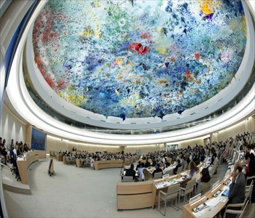
UN Human Rights Council
A list of individuals and entities allegedly responsible for crimes in the Syria Arab Republic war has just been released by a UN panel investigating human rights abuses in the country.
The news was announced during an interactive dialogue on Tuesday in Geneva at the UN Human Rights Council.
An estimated 100,000 lives have been lost to the conflict and over 9 million people have been forced to leave their homes.
Jocelyne Sambira reports.
Duration: 3’32″

